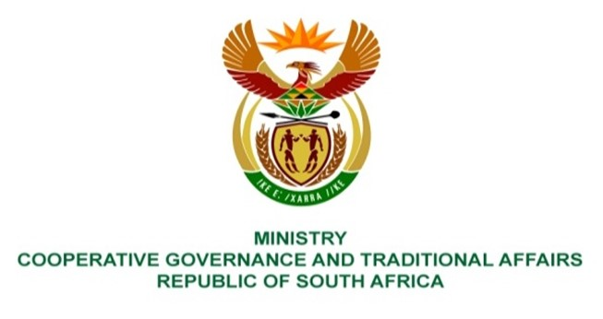

NATIONAL ASSEMBLY
QUESTIONS FOR WRITTEN REPLY

QUESTION NUMBER 865
DATE OF PUBLICATION: 17 MARCH 2023
865. Mrs S M Mokgotho (EFF) to ask the Minister of Cooperative Governance and Traditional Affairs:
Whether she has taken any intervening steps as provided for in the Constitution of the Republic, 1996, to ensure that repairs are conducted on the roads of Ward 4 in the Ditsobotla Local Municipality which are riddled with potholes; if not, why not; if so, what are the further, relevant details?
REPLY:
Yes, the Minister of Cooperative Governance and Traditional Affairs supported Ditsobotla Local Municipality (DLM) in accordance with section 154 of the Constitution by deploying, through the Municipal Infrastructure Support Agent (MISA), four professionally registered built environment practitioners that include two Civil Engineers to support DLM, together with other municipalities within Ngaka Modiri District Municipality (NMDM), in accordance with the District Development Model (DDM). These professionals provide technical support to DLM for infrastructure development throughout the project life cycle from inception, planning, design development, implementation, operations and maintenance that includes roads repairs and refurbishments. Furthermore, DLM was allocated R41 395 000 (R41,395 million) of the Municipal Infrastructure Grant (MIG) that is administered by the Department of Cooperative Governance (DCOG) in the 2022-23 financial year. The MISA deployed professionals provide DLM with both MIG programme support as well as respective MIG funded projects support. The MISA professionals are currently supporting DLM with the implementation of a MIG funded road network upgrading project of R 23 278 513.44 in Blydeville which is in Ward 4. The project is scheduled to be completed in the next financial year. The deployed MISA professionals are supporting DLM to prioritise and plan roads repair projects to be implemented by the North-West Province Department of Public Works and Roads (NWPDPWR) after the signing of a Memorandum of understanding (MOU) on 14 November 2022 between NWPDPWR and DLM. The MOU aims to assist DLM by NWPDPWR with repairing and maintenance of municipal roads. The MOU will be reviewed after a year.

Ditsobotla Local Municipality has been experiencing perennial governance and administration challenges resulting in its failure to fulfil its constitutional obligations including sustainable service delivery. The North-West Provincial Executive Council resultantly intervened by invoking Section 139 of the Constitution which is currently in place. DCOG is monitoring the provincial executive intervention. Section 139 (7) of the Constitution provides, among other things, that if the provincial executive does not adequately exercise the powers or perform the functions the national executive must then intervene.
End.

