

**DEPARTMENT: PUBLIC ENTERPRISES**

**REPUBLIC OF SOUTH AFRICA**

**NATIONAL ASSEMBLY**

**QUESTION FOR WRITTEN REPLY**

**QUESTION NO.: PQ 865**

**QUESTION:**



**865.     Mr G K Y Cachalia (DA) to ask the Minister of Public Enterprises:**

(1) Whether he will furnish Mr G K Y Cachalia with a reasonable data-driven estimate on how much more each one of the seven state-owned entities reporting to him spend on a basket of recurring consumables such as bottled water, toilet paper, milk, cleaning products and implements, as (a) a result of the application of the current procurement regime governed by internal procurement manuals and the Public Financial Management Act, Act 1 of 1999, and (b) against normal wholesale and/or even retail prices; if not, why not; if so, what are the relevant details;

(2) How has he found that the quantum of the difference, extrapolated across the total spend, might impact cash flow and profitability?                 NW1030E

**REPLY:**

**According to the information received from Alexkor:**

|  |  |  |  |  |
| --- | --- | --- | --- | --- |
| 1. Alexkor has always bought these items directly from the main retailers. They are not procured through a third party | | | | |
|  | | | | |
| **Consumables** | **YTD Spend** | **Forecast YE Spend** |
| Cleaning products | R12,210 | R13,320 |
|  |  |  |

**According to the information received from Denel:**

(1)(a) Denel, due to continued and prolonged liquidity challenges do not procure bulk bottled waters, milk etc. Cleaning material is part of the Cleaning contracts, which is a consequence of the competitive bidding process.

(1)(b) N/A

(2) N/A

**According to the information received from Eskom**

Background

Eskom’s Procurement and Supply Chain Management Procedure states that all prices paid need to be market related, thereby minimising the total cost of ownership. The cost of ownership may include items such as delivery, which could be included with each payment invoice. Eskom has since introduced various mechanisms, namely Price Check, e-Auction, Cataloguing, etc., which are embedded in the procurement system to ensure that the principle of obtaining market related prices is adhered to across Operating Units.

The data used to calculate the estimate for Eskom’s spend per unit on a basket of recurring consumables such as bottled water, toilet paper, milk, cleaning products and implements was extracted from SAP based on the text descriptions.

Eskom systems capture information at invoice level not per unit price. In order to respond to this question, Eskom undertook a manual exercise in order to remove items that are not related to the question, and obtained feedback at local level i.e. stations, operating units and offices.

1. (a) The outcome of an exercise undertaken to determine a reasonable estimate for Eskom’s spend per unit on a basket of recurring consumables, such as bottled water, toilet paper, milk, cleaning products and implements, is summarised in Table 1 below. The total spend in April 2020 to February 2020 was R15.6 million - 47% less than the 2019/20 financial year spend.

|  |  |  |  |
| --- | --- | --- | --- |
| Category | Currency | FY 2019/20 | 1 April 2020 to 28 February 2021 |
| Milk | ZAR | 16 955 622 | 7 194 810 |
| Toilet paper | ZAR | 5 560 989 | 2 804 401 |
| Bottled water | ZAR | 382 566 | 258 627 |
| Cleaning products and implements | ZAR | 6 456 299 | 5 383 989 |
| Total |  | 29 355 476 | 15 641 827 |

Table 1: Total spend on bottled water, toilet paper, milk, cleaning products and implements

81.47% of the transactions for the last financial year were procured using the local purchase order (LPO)

* According to Eskom Procurement Procedure 32-1034, LPO is a procurement mechanism to be used by an accredited LPO-buyer to procure specific confined categories of goods and services in accordance with the prescribed Delegation of Authority Policy thresholds. The LPO is seen to procure specific confined categories of goods and services below the value of R26 000, excluding VAT.
* The spend on these items is considered as ‘low value’, and most spend is not on long term contracts. This is as a result of Eskom’s footprint across multiple sites, across the country. Further these items are procured locally, preferably local to site, in order to support to local business.
* Since LPO is the main procurement mechanism used, the transaction captured on the system could only reflect the total amount paid. This means the unit data is not standardised and could include varying unit sizes e.g. 20litres of milk, a six pack or 1 litre. This applies to cleaning materials.

(b) A total of 1646 transactions were identified for the period 1 April 2020 to 28 February 2021 and 73%, i.e. 1215 transactions, were analysed further.

In terms of wholesale or retail prices, the results of the price comparison are as set out in Table 2.

Eskom notes that the unit prices paid are above market rates. This is being attended to.

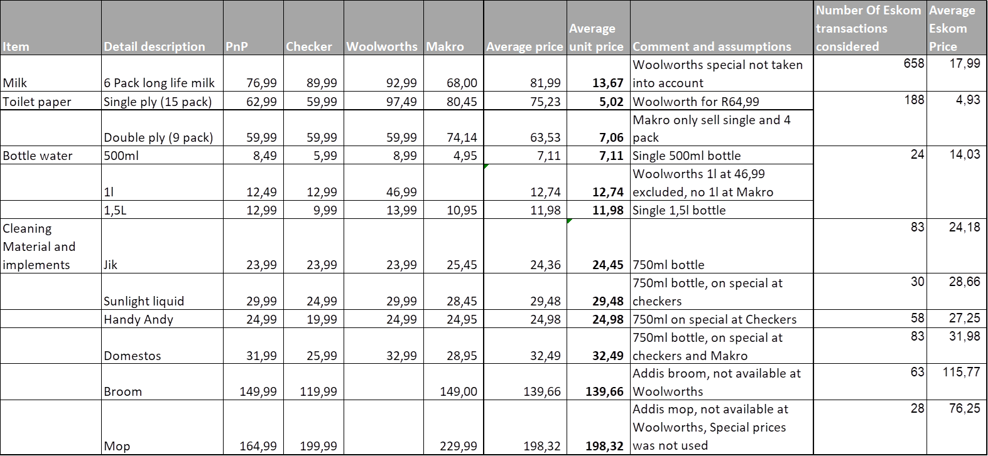

Table 2: Price comparison for bottled water, toilet paper, milk, cleaning products and implements

In terms of cleaning products and implements:

* Cleaning services are mostly procured as a combined service including labour, material and equipment, therefore it is not easy to identify cleaning products and implements costs.
* There are other costs included in the transactions such as transport and delivery cost. Therefore the individual items could not be rolled up accurately.

1. Eskom’ spend per unit on a basket of recurring consumables such as bottled water, toilet paper, milk, cleaning products and implements is a very small portion (less than 0.01%) of the total spend. Therefore it should not be extrapolated across the total spend, to make any conclusions on the rest of the Eskom spend.

The analysis presented above has been shared with the business and guidance on LPO usage will be provided to the business, since it is monitored at local level.

Overall, the exercise did not reveal issues that would impact on cash flow and profitability.

**According to the information received from SAFCOL :**

**1 (a) SAFCOL procurement (2019/2020 FY)**

|  |  |  |  |
| --- | --- | --- | --- |
| **Bottled Water 500l** | **Toilet Paper one ply pack 24** | **Milk 1Litre** | **Cleaning Products** |
| **Average Unit Price** | **Average Unit Price** | **Average Unit Price** | **Average Unit Price** |
| R12.00 | R290.00 | R18.00 | Handy Andy 750ML=R30.00  Pine Gel 5Litre =R180.00  Bleach 5 Litre =R70.00  Domestos 5 Litre = R150.00 |
| Total Spend for the Financial Year  **R3 000.00** | Total Spend for the Financial Year  **R120 000.00** | Total Spend for the Financial Year  **R15 000.00** | Total Spend for the Financial Year  **R70 000** |

**1(b) Wholesale prices (2019/2020 FY)**

|  |  |  |  |  |
| --- | --- | --- | --- | --- |
| **Description** | **Bottled Water** | **Toilet Paper** | **Milk** | **Cleaning Products** |
| Unit Price | R14.00 | R250.00 | R14.00 | Handy –Andy 750ML =R25  Pine Gel 5L =R150  Bleach 5L =R50  Domestos =R120 |
| Comments | The price varies depending on the brand or the supplier | The price varies depending on the brand or the supplier | The price varies depending on the brand or the supplier | The price varies depending on the brand or the supplier |

2. Total spend does not affect cash flow nor profitability.

**According to the information received from South African Express:**

Not applicable. The SOC is under liquidation.

**South African Airways:**

The information from this entity is outstanding and will be submitted as soon as it becomes available.

**According to the information received from Transnet:**

1.(a) &(b): **Annexure A** provides details of the spend on a basket of recurring consumables.

2. The rate differences per annum for recurring consumables will not have an impact on the profitability or the cash flow of Transnet. Transnet has no long term agreements in place for consumable items and frequent RFQ’s are issued out to the market in order to ensure that the prices paid remain market related. There are certain instances that Transnet pays below the market rate for consumables and this compensates for the items procured above market rate.

**Remarks: Reply: Approved / Not Approved**

**Kgathatso Tlhakudi Pravin Gordhan, MP**

**Director-General Minister of Public Enterprises**

**Date: Date:**