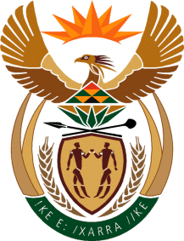

MINISTRY OF TOURISM
REPUBLIC OF SOUTH AFRICA

Private Bag X424, Pretoria, 0001, South Africa. Tel. (+27 12) 444 6780, Fax (+27 12) 444 7027
Private Bag X9154, Cape Town, 8000, South Africa. Tel. (+27 21) 469 5800, Fax: (+27 21) 465 3216

NATIONAL ASSEMBLY:

QUESTION FOR WRITTEN REPLY:
Question Number: 864
Date of Publication: 17 March 2023
NA IQP Number: 10
Date of reply:

Mr A Matumba (EFF) to ask the Minister of Tourism:

What total (a) number of small, medium and micro enterprises (SMMEs) were supported by her department to exhibit in Meetings Africa 2023 and (b) budget was spent to support SMMEs to participate in the specified event? NW970E

REPLY:

(a) I have been informed by the Department that the total number of small, medium and micro enterprises (SMMEs) that were supported by the Department to exhibit in Meetings Africa 2023 were Eighteen (18).

(b) Participation and exhibition cost of R1 065 552,95 has been paid by the Department.

The Department is awaiting final invoices for the approved flights and accommodation of supported enterprises, as well as outstanding claims from some of the supported enterprises for costs incurred on ground transport and shuttle services.

Thus the total estimated cost of support for the 18 enterprises that participated at Meetings Africa 2023 is not finalised.

