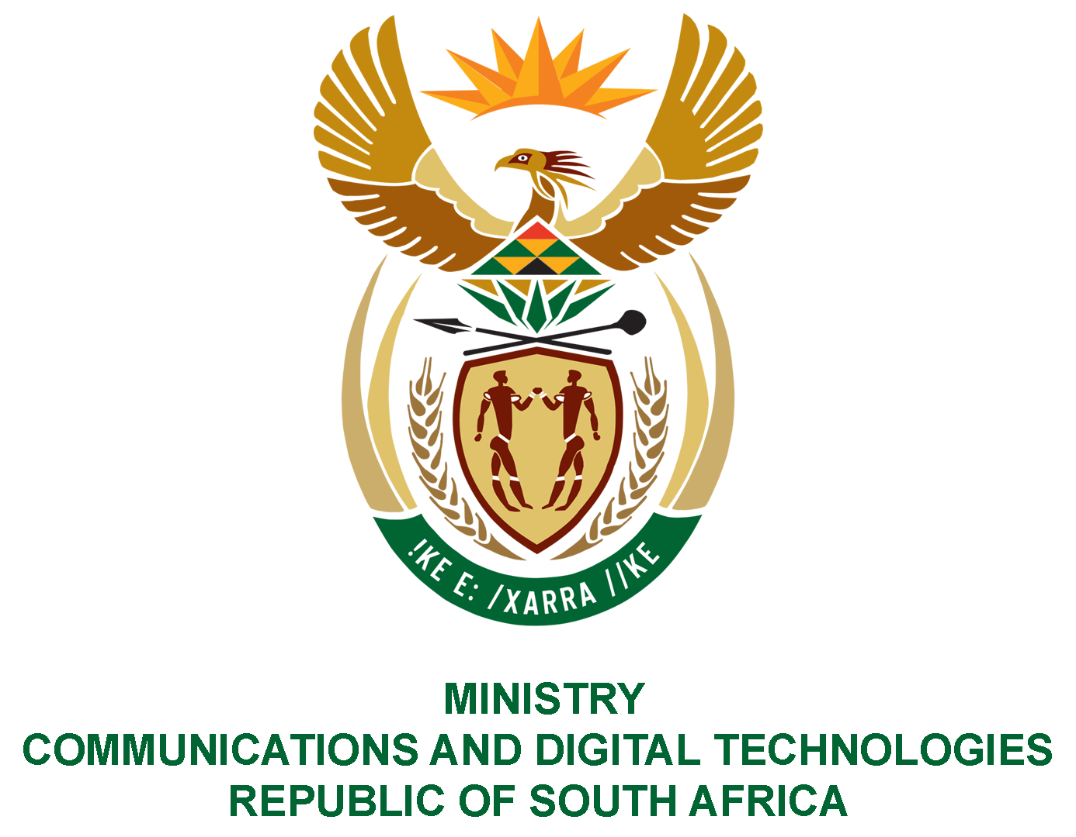

PARLIAMENT OF THE REPUBLIC OF SOUTH AFRICA
NATIONAL ASSEMBLY
WRITTEN REPLY

QUESTION NO: 864
DATE OF PUBLICATION: 15 May 2020
QUESTION PAPER NO: 15

Mr H C C Krüger (DA) to ask the Minister of Communications & Digital Technologies:

- Whether her department will offer any form of Covid-19 financial and/or other relief to small businesses; if not, why not; if so, what are the relevant details;
- Whether the Covid-19 financial and/or other relief will only be allocated to qualifying small businesses according to the Broad-Based Black Economic Empowerment Act, Act 53 of 2003, as amended; if not, what is the position in this regard; if so, (a) on what statutory grounds and/or provisions does she or her department rely to allocate Covid-19 financial or other relief only to small businesses according to the specified Act and (b) what form of Covid-19 financial or other relief, if any, will be made available to other small businesses? (NW1071E)

REPLY:

I have been advised as follows:
- No, the department does not offer financial assistance and/or other relief to small businesses. The department has not budgeted for such.
- The Independent Communications Authority of South Africa [ICASA], an entity of the department, has written to licensees in an effort to ensure that they make communication services available to all South Africans. ICASA provided concessions or relaxations to enable the sector to meet the demands of business unusual environment brought about by COVID-19.
ICASA has exempted television broadcasting service licensees from compliance with the local television content quotas and specific advertising and programming requirements in terms of licence conditions during the National State of Disaster.
Sound broadcasting service licensees are exempted from compliance with specific programming requirements and promises of performance in terms of licence conditions during the National State of Disaster. However, sound broadcasting service licensees shall comply with the local content music quotas.
These exemptions will automatically cease three months after termination of the National State of Disaster.

MR J MTHEMBU, MP
ACTING MINISTER OF COMMUNICATIONS AND DIGITAL TECHNOLOGIES

