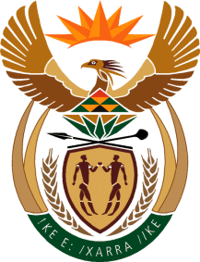

MINISTRY OF TOURISM
REPUBLIC OF SOUTH AFRICA

Private Bag X424, Pretoria, 0001, South Africa. Tel. (+27 12) 444 6780, Fax (+27 12) 444 7027
Private Bag X9154, Cape Town, 8000, South Africa. Tel. (+27 21) 469 5800, Fax: (+27 21) 465 3216

NATIONAL ASSEMBLY:

QUESTION FOR WRITTEN REPLY:
Question Number: 86
Date of Publication: 13 February 2020
NA IQP Number: 1
Date of reply: 25 February 2020

Mr M S F De Freitas (DA) to ask the Minister of Tourism:

Whether there are any plans put in place to undertake studies on brand positivity by tourists and/or potential tourists to the Republic; if not, what is the position in this regard; if so, what are the (a) deadlines, (b) milestones and (c) timelines in this regard? NW95E

REPLY:

Whether there are any plans put in place to undertake studies on brand positivity by tourist and / or potential tourist to the Republic.

SA Tourism does conduct brand positivity studies through an in-depth assessment of travellers' perceptions of South Africa as a leisure travel destination across key priority markets. The aim of the study is to inform the key marketing and strategic initiatives of SA Tourism; thereby, improving the return on marketing investment in each market.

(a)–(c) The study is currently carried out 3 times a year during the major booking and buying cycle of our target markets. SA Tourism currently runs the study in 17 of the core markets.

