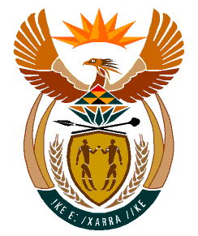

MINISTRY:
HUMAN SETTLEMENTS, WATER AND SANITATION
REPUBLIC OF SOUTH AFRICA

NATIONAL ASSEMBLY

QUESTION FOR WRITTEN REPLY

QUESTION NO.: 86

DATE OF PUBLICATION: 20 JUNE 2019

Ms N P Sonti (EFF) to ask the Minister of Human Settlements, Water and Sanitation:

With reference to the reply to question 53 on 11 March 2019, what is the total number of persons living in each informal settlement in each province? NW1044E

REPLY:
The number of persons living in each informal settlement in each province are given in the attached Annexure A. The status of the information is as at November 2017, based on information provided by Provinces and some Metropolitan municipalities, as well as information gathered by the Department during the informal settlement assessments, categorisation and development of the upgrading plans.

