FOR WRITTEN REPLY QUESTION 86

NATIONAL ASSEI\ABLY
36/11411(201900008)

DATE OF PUBLICATION IN INTERNAL QUESTION PAPER: 7 FEBRUARY 2019 (INTERNAL QUESTION PAPER NO 1-2019)

86. Mr J H Steenhuisen (DA) to ask the Minister of Police:

- What is the current status of the investigation into CAS 501/04/2017 opened at the Randfontein Police Station in Gauteng;

- what are the names of the investigating officer(s) who was or were assigned to investigate the charges;

- whether the case has been finalised; if not, what is the envisaged date for the
finalisation of the case; if so, what are the details of the outcome of the case?
NW91E
REPLY:

The Inquest docket, Randfontein, CAS 501/04/2017, was opened after an explosion at Wilmar Continental Oils, Randfontein, at the SalVent Plant, where one person succumbed to his injuries. The case docket was discussed with the Senior Public Prosecutor (SPP), who instructed that the case be referred to the Occupational Health and Safety Department, in Johannesburg, for a report. The case docket was sent to the Occupational Health and Safety Department, on 16 July 2018. The report from the Occupational Health and Safety Department is outstanding.

- In the interest of the case being investigated without fear or favour, the particulars of the investigating officer cannot be divulged.

- Yes, the investigation of the case docket was finalised by the South African Police Service (SAPS) and referred to the SPP for a decision. The SPP instructed that the incident must be referred to the Occupational Health and Safety Department, for a report. This report is still outstanding. As soon as the report is received, the case docket will be returned to the SPP at the Randfontein Magistrate’s Caurt. The date of the finalisation of this case

2

cannot be provided, as the court process is managed by the Department of Justice and Constitutional Development.

Reply to question 86 recommended

OM
KJ 2E (SOEG)

Date: 201tl -0t- 0 t

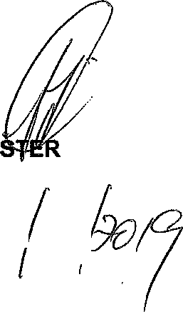
Reply to question 86 approved/

MINI OF POLICE BH CELE, MP

Date:/ D
GENERAL H AFRICAN POLICE SERVICE

