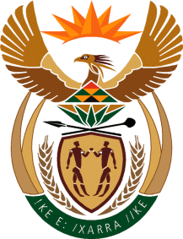

MINISTRY OF TOURISM
REPUBLIC OF SOUTH AFRICA

Private Bag X424, Pretoria, 0001, South Africa. Tel. (+27 12) 444 6780, Fax (+27 12) 444 7027
Private Bag X9154, Cape Town, 8000, South Africa. Tel. (+27 21) 469 5800, Fax: (+27 21) 465 3216

NATIONAL ASSEMBLY:
QUESTION FOR WRITTEN REPLY:
Question Number: 86
Date of Publication: 8 February 2018
NA IQP Number: 1
Date of reply: 20 March 2018

Mr G R Krumbock (DA) to ask the Minister of Tourism

What (a) was the original budgeted cost of the Royal Khalanga Lodge in Limpopo, (b) additional costs have been incurred over and beyond the original budget, (c) are the estimated costs to complete the project and (d) is the estimated total cost of the project upon completion? NW92E
Reply:
- What was the original budgeted cost of the Royal Khalanga Lodge in Limpopo?
Phase 1: (June 2010 – June 2012) – The budget was R19, 000,000
Phase 2: (February 2014 – April 2016) – The budget was R23, 512,500,000

- What additional costs have been incurred over and beyond the original budget?
Phase 1: No additional costs were incurred over and beyond the original Phase 1 budget.
Phase 2: No additional costs were incurred over and beyond the original Phase 2 budget.

- What are the estimated costs to complete the project?
The project is completed. The actual costs incurred for:
Phase 1: Actual cost incurred was R18, 853,709 and for
Phase 2: Actual cost incurred wad R23, 347,912.

- What is the estimated total cost of the project upon completion?
The project is completed. The actual total costs incurred for both Phases 1 and 2 is: R42, 201, 621.

