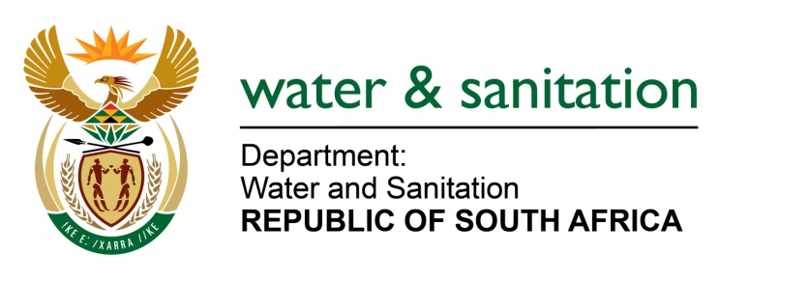

NATIONAL ASSEMBLY

FOR WRITTEN REPLY

QUESTION NO 859

DATE OF PUBLICATION IN INTERNAL QUESTION PAPER: 18 MARCH 2016
(INTERNAL QUESTION PAPER NO. 9)

859. Ms M S Khawula (EFF) to ask the Minister of Water and Sanitation:
When is the community of Siyancuma in the Northern Cape, Huhudi and Ipeleng in North West and Thabo Mofutsanyana District Municipality in Free State going to get water? NW979E
---00O00---
REPLY:

The responsibility to provide water to households in the Municipalities lies with the respective Water Service Authorities in the different provinces as follows:
- Northern Cape: Pixley ka Seme District Municipality
- North West Province: Dr Ruth Segomotsi Mompati District Municipality
- Free State Province: Thabo Mofutsanyana District Municipality

---00O00---

