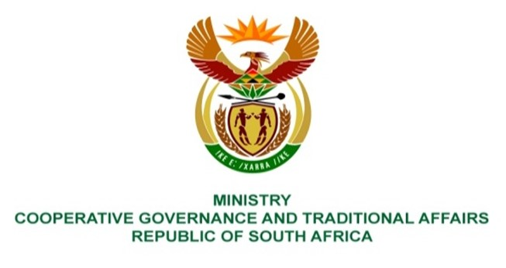

NATIONAL ASSEMBLY
QUESTIONS FOR WRITTEN REPLY

QUESTION NUMBER 852
DATE OF PUBLICATION: 7 MARCH 2023

852. Mr K Ceza (EFF) to ask the Minister of Cooperative Governance and Traditional Affairs:

Whether, in light of the mandate of the Municipal Demarcation Board (MDB), she has the power to take steps to ensure that the Independent Electoral Commission obtains a seat on the MDB in order to fulfil the objectives on cross-cutting problems of municipalities; if not, what is the position in this regard; if so, what are the relevant details? NW958E

REPLY:
I have no power to take steps to ensure that the Independent Electoral Commission obtains a seat on the Municipal Demarcation Board. The Board consists of no fewer than seven and no more than 10 members appointed by the President in accordance with section 8 of the Local Government: Municipal Demarcation Act No. 27 of 1998 (“the Act”). The Act also requires the selection panel to consider all applications and from amongst the applicants compile a list of nominees which must then be submitted to the Minister, whereafter the President must make the required number of appointments from the list.
End.

