36/1/4/1(201900203)
NATIONAL ASSEMBLY

FOR WRITTEN REPLY QUESTION 851
DATE OF PUBLICATION IN INTERNAL QUESTION PAPER: 6 SEPTEMBER 2019 (INTERNAL QUESTION PAPER NO 14-2019)

851. M. Gen O S Terblanche (DA) to ask the Minister of Police:

- What is the protocol with regard to police stations having cameras in the (a) customer care centre/charge office, (b) cells and (c) any other part of the police station;

- how often are the cameras inspected in order to ensure they are in proper working condition?
NW1971E
REPLY:

(1)(a)(b)(c) There are no specific, formalised and approved prescripts, relating to the use of closed circuit television (CCTV) cameras in client service centres, cells or any other part of police stations.
(2) A contract has been drafted that includes maintenance and prescribes the formal inspection of CCTV cameras every six months, for systems which will be installed and maintained, in accordance with the contract, once the contract is established.

Reply to question 851 recommended/

GENERAL
L CO’
LE (SOEG)
NER:
H AFRICAN POLICE SERVICE

Date: ITU l0- 11

2

Reply to question 851 appro\led/oat-aggro
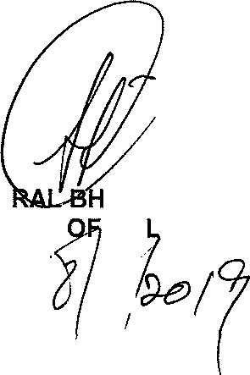
GENE MINISTER
CELE (MP) PO ICE

