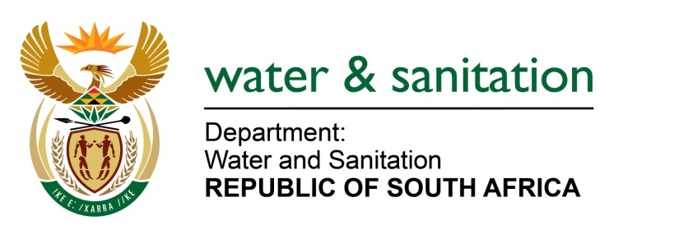

NATIONAL ASSEMBLY

FOR WRITTEN REPLY

QUESTION NO 848

DATE OF PUBLICATION IN INTERNAL QUESTION PAPER: 31 MARCH 2017
(INTERNAL QUESTION PAPER NO. 12)

848. Mr T J Brauteseth (DA) to ask the Minister of Water and Sanitation:

(1) With reference to her department’s acknowledgement that certain areas in the North West still require support, as indicated in her department’s presentation to the Portfolio Committee on Water and Sanitation on 1 March 2017, (a) how is her department going to support the (i) NgakaModiriMolema and (ii) Dr Ruth Mompati District Municipalities, (b) who will be responsible for the implementation of the support and (c) when will the support commence;

(2) whether her department will support the specified district municipalities to address the water crisis caused by the low levels of the Wentzel Dam and declining yields in boreholes; if not, why not; if so, (a) in what ways will her department be supporting the specified district municipalities in this regard, (b) when will the support commence and (c) who will be responsible for the implementation of this assistance? NW913E
---00O00---
REPLY:
Requesting the Honorable Member to refer to the response provided in NA 579 of 10 March 2017.
---00O00---

