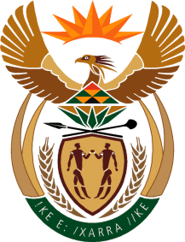

MINISTRY OF TOURISM
REPUBLIC OF SOUTH AFRICA

Private Bag X424, Pretoria, 0001, South Africa. Tel. (+27 12) 444 6780, Fax (+27 12) 444 7027
Private Bag X9154, Cape Town, 8000, South Africa. Tel. (+27 21) 469 5800, Fax: (+27 21) 465 3216

NATIONAL ASSEMBLY:

QUESTION FOR WRITTEN REPLY:
Question Number: 847
Date of Publication: 15 May 2020
NA IQP Number: 15
Date of reply: 28 May 2020

Mr H S Gumbi (DA) to ask the Minister of Tourism:
What (a) total number of applications for Covid-19 funding relief have been received through the Tourism Relief Fund in each province to date, (b) number of the specified applications have been (i) approved and (ii) rejected in each case in each province and (c) was the Rand value of each (i) approved and (ii) rejected application in each case in each province? NW1054E

REPLY:

The Department of Tourism established the Tourism Relief Fund as a measures to mitigate the negative economic effects caused to tourism businesses by the coronavirus pandemic.

a). What are the total number of applications for Covid-19 funding relief have been received through the Tourism Relief Fund in each province to date?

The Department is currently in the process of receiving and processing applications from enterprises affected by coronavirus pandemic. As soon as the process is completed, details with regard to the number of applications received, processed and the outcomes of applications will be communicated.
b). (i) (ii). Not applicable
c). (i) (ii). Not applicable

