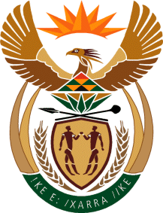

Ministry
Employment & Labour
Republic of South Africa
Private Bag X499, PRETORIA, 0001. Laboria House 215 Schoeman Street, PRETORA Tel: (012) 392 9620 Fax: 012 320 1942
Private Bag X9090, CAPE TOWN, 8000. 120 Plein Street, 12th Floor, CAPE TOWN Tel: (021) 466 7160 Fax 021 432 2830
www.labour.gov.za

NATIONAL ASSEMBLY

WRITTEN REPLY

QUESTION NUMBER: 844 [NW950E]

844. Mr M K Montwedi (EFF) to ask the Minister of Employment and Labour:
What total number of electricians are registered in the Republic since 1 January 2015? NW950E
REPLY:
National Skills Authority is not an entity of the Department of Employment and Labour. This entity resides in the other sister department. We can therefore reply to your question by stating what is in our purview, the total number of registered persons that have been registered in terms of the Electrical Installation Regulations of the Occupational Health and Safety Act, Act 85 of 1993, as amended, since 1 January 2015 is 8512. They are registered in the following categories:
Electrical Testers for Single Phase: 2814
Installation Electricians: 5387
Master Installation Electricians: 311

