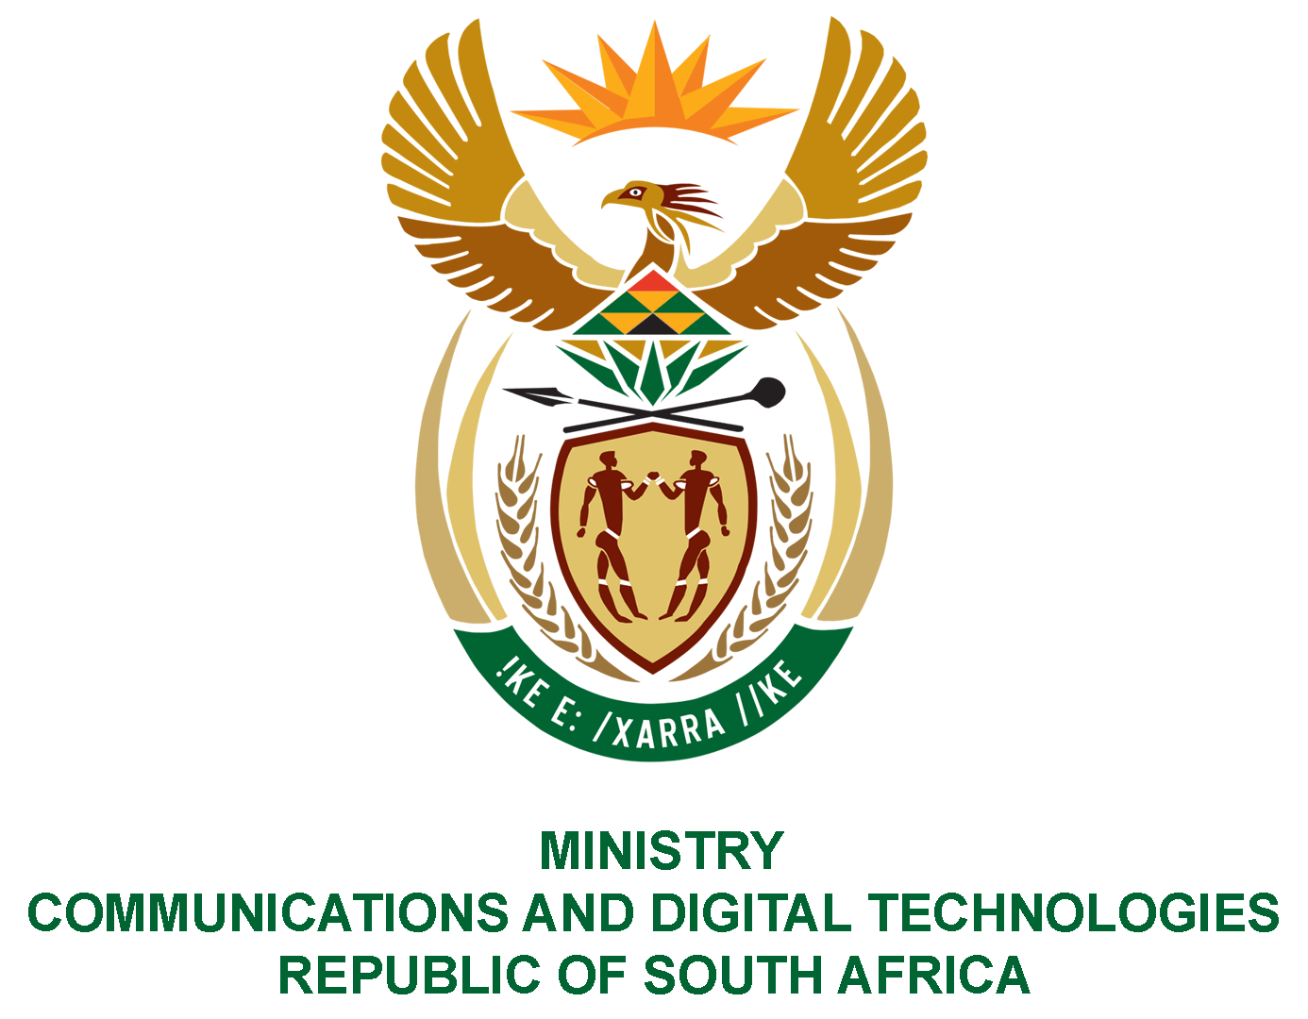

PARLIAMENT OF THE REPUBLIC OF SOUTH AFRICA

NATIONAL ASSEMBLY

WRITTEN REPLY

QUESTION: 843

DATE OF PUBLICATION: 11 MARCH 2022
QUESTION PAPER NO: 09

Mr M Bagraim (DA) to ask the Minister of Communications and Digital Technologies:

What total amount in Rand has been spent on (a) catering, (b) entertainment and (c) accommodation for (i) her, (ii) the Deputy Minister and (iii) officials of her department since 29 May 2019?

NW1024E

REPLY

I have been advised by the Department as follows:
- The total amount spent on catering for the period in question was R738 982.91,

- Minister: R157 644.86

- Deputy Minister: R 90 665.20

- Officials in the Department: R490 672.85

- The total amount spent on entertainment for the period in question was R0.00,

- Minister: R0.00

- Deputy Minister: R0.00

- Officials in the Department: R0.00

- The total amount spent on accommodation for the period in question was R15 345 562.86

- Minister: R 3 615 001.95

- Deputy Minister: R 1 021 003.90

- Officials in the Department: R10 709 557.01

Authorised for submission by

MS. NONKQUBELA JORDAN-DYANI
DIRECTOR-GENERAL (ACTING)
DATE:

Recommended/not recommended

__________________________
HON. PHILLY MAPULANE, MP
DEPUTY MINISTER
DATE:

Approved/ not approved

________________________________
HON. KHUMBUDZO NTSHAVHENI, MP
MINISTER
DATE:

