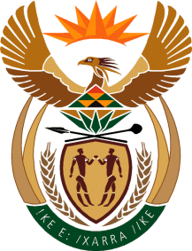

MINISTRY OF TOURISM
REPUBLIC OF SOUTH AFRICA

Private Bag X424, Pretoria, 0001, South Africa. Tel. (+27 12) 444 6780, Fax (+27 12) 444 7027
Private Bag X9154, Cape Town, 8000, South Africa. Tel. (+27 21) 469 5800, Fax: (+27 21) 465 3216

NATIONAL ASSEMBLY:

QUESTION FOR WRITTEN REPLY:
Question Number: 843
Date of Publication: 15 May 2020
NA IQP Number: 15
Date of reply: 28 May 2020

Mr H S Gumbi (DA) to ask the Minister of Tourism:
With reference to the reprioritisation of the budget of her department as a result of Covid-19, what (a) changes will be made in the budget per line item, (b) criteria will be used to (i) increase and/or (ii) decrease line items and (c) are the relevant amounts in each case? NW1050E

REPLY:

The department has reviewed its Annual Performance Plan for 2020/21-2022/23 due to the anticipated impact of Covid-19 on its outputs and targets and the tourism sector, however the budget in the Reviewed Annual Performance Plan is still the same as the budget in the Estimate of National Expenditure that was tabled to Parliament on 26 February 2020. Changes to the budget can only be finalised once the department receive a revised budget from National Treasury. This will happen after the special adjustment budget of the Minister of Finance. At this stage the department is unable to disclose the estimates on the increase and decreases per line item due to the reason stated above.

