FOR WRITTEN REPLY

NATIONAL ASSEMBLY
36/1/4/1(201900193)

QUESTION 840

DATE OF PUBLICATION IN INTERNAL QUESTION PAPER: 6 SEPTEMBER 2019 (INTERNAL QUESTION PAPER NO 14-2:04 9)

840. Dr A Lotriet (DA) to ask the Minister of Police:

- (a) What number of cameras are at the Boksburg North Police Station and (b) where is each camera situated;

- (a) when last was each camera inspected, (b) what was the working condition of each camera and (c) on what date was each faulty camera repaired;
- (a) when last did the specified police station report any camera that was out Of order, (b) when were the reported cameras repaired and (c) for how long f3as each camera been out of order?

REPLY:

(1)(a)

(1)(b)

(2)(a)

(2)(b)

(2)(c)
NW196OE

There are nine cameras installed at the Boksburg North Police StatioU

Due to the nature of the information that is required, the South Africa U Police Service (SAPS) cannot provide these details. The response w'ilI contain details that may pose a security risk.
The last inspection was on 27 November 2018. All the cameras are in good working condition. Not applicable.

(3)(a)(b)(c) Not applicable.

Reply to question 840 recommended/

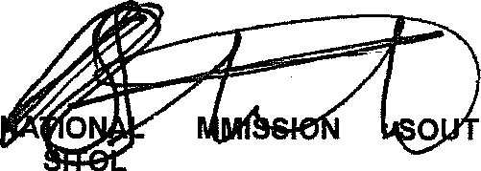GENERAL
KJ
CO
E (SOEG)
ER'
H AFRICAN POLICE SERVICE

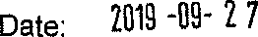

Reply to question 840 approved/cot-a

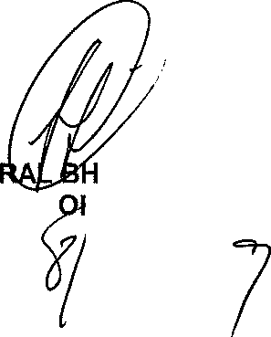

GENE CELE (MP) MINISTER ) CE

