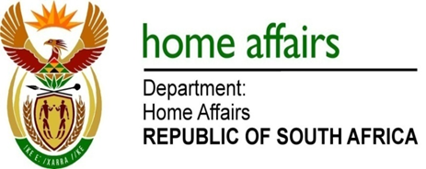

NATIONAL ASSEMBLY

QUESTION FOR WRITTEN REPLY

QUESTION NO. 839

DATE OF PUBLICATION: FRIDAY, 16 MARCH 2018

INTERNAL QUESTION PAPER 8 OF 2018

839. Mrs A M Dreyer (DA) to ask the Minister of Home Affairs:

(1) Whether, with reference to the reply to question 3976 on 18 December 2017, the Electoral Commission of South Africa reported any offences contained in the Public Protector’s report to police officials in accordance with section (34) of the Prevention and Combating of Corrupt Activities Act, Act 12 of 2004; if not, why not; if so, (a) what are the relevant details of each such report, (b) to whom was it reported, (c) who reported it and (d) what is the case number? NW924E

REPLY:

- The Electoral Commission (the Commission), can confirm that there was an investigation that was conducted by the Specialised Commercial Crime Unit in relation to the Public Protector’s Report. The Electoral Commission can also confirm that the Specialised Commercial Unit had finalised the investigation and indicated that there was no reasonable prospect of a successful prosecution.

(a)-(c) The details of the report to the Specialised Commercial Crime Unit, as well as the person to whom such report was filed, including the complainant in this matter is currently unknown to the Commission. The Commission has in the meantime requested such information from the Gauteng Regional Head of the Specialised Commercial Crime Unit, and will furnish such information as soon as it is in receipt of same.

(d) The case number is Sunnyside CAS 738/09/2014.

