FOR WRITTEN REPLY
QUESTION 837

NATIONAL ASSEIYIBLY
36/1/4/1(201900211)

DATE OF PUBLICATION IN INTERNAL QUESTION PAPER: 6 SEPTEMBER 2019 fINTERNAL QUESTION PAPER NO 14-2019)
837. Mr M Waters (DA) to ask the Minister of Police:

- With regard to SA Police Service (SAPS) 13-Store where all evidence is kept, what (a) number of items/exhibits (i) went missing, (ii) were tampered with and/or (iii) returned by forensics at the Edenvale Police Station (aa) in each of the past three financial years and (bb) since 1 April 2019 and (b) items went missing in each case;

- what (a) is the name of the police officer who was responsible for the SAPS 13 when each of the above incidents took place and (b) action was taken against the specified person(s) in each case;

- whether the police officer who was in charge of SAPS 13 in each case passed all the necessary courses in order to be in charge of SAPS 13; if not, (a) why not and \b) how were they allowed to be in charge of SAPS 13 without passing the necessary courses?

REPLY:
(1)(a)(i)(ii)(iii)(aa)(bb)(b)
NW1957E

 |  | (aa) 2016/2017 | (aa) 2017/2018 | (aa) 2018/2019 | (bb)  Since 1 April  2019
(1 | /a)(i) Missing | 0 | 0 | 1 | 0
(1 | (a)(ii) Tampered with | 0 | 0 | 1 | 0
1 | (a)(N) Returned by Forensics | 0 | 0 | 0 | 0

(1)(b) The exhibit that was tampered with, in 2018/2019, was suspected narcotics. A criminal case was opened and it is being investigated, as per Edenvale, CAS 247/09/2019.
The item that went missing, in 2018/2019, was a cellular telephone. A criminal case was registered and it is being investigated, as per Edenvale, CAS 215/01/2019.
(2)(a) Sergeant AC Tokwana.

(2)(b) Criminal and departmental cases, which are still under investigation, were opened.

(3)(a) Yes, the member did attend the Evidence Management Course.
(3)(b) Not applicable.

Reply to question 837 recommended/

KJ LE (SOEG)

Date: tt1t -1!- 1
GENERAL

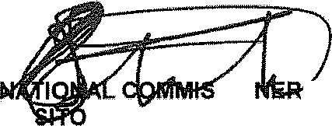
SO fSOUTMAFRlCANPOLlCESERVlCE

Reply to question 837 approved/ o d
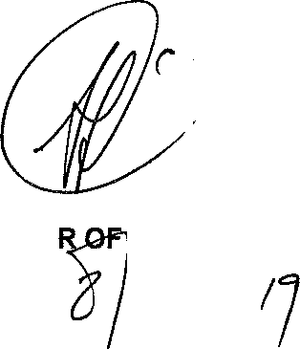

GENERAL BH CELE (MP) MINISTE ) E

