PRIVATE BAG x 59, PRETORIA, 0001, Tel (012) 444 3979, Fax (012) 444 3145
PRIVATE BAG x 9111, CAPE TOWN, 8000 (021) 462 2310, Fax (021) 461 0859
Enquiries: Carmichael Ngalo O Carmichael. ngaloG'dmr.gov.za

Memorandum: Parliamentary Liaison Office

NATIONAL ASSEMBLY QUESTION FOR WRITTEN REPLY QUESTION NUMBER: 83 ADVANCE NOTICE No: NW 1041E
DATE OF PUBLICATION IN INTERNAL QUESTION PAPER: 20 June 2019 INTERNAL QUESTION PAPER NUMBER: 01

- Mr M M Dlamini (EFF) to ask the Minister of Mineral Resources and Energy:

  - What number of (i) buildings, (ii) properties and (iii) facilities does his department currently (aa) own and (bb) rent, (b) what is the value and purpose of each (i) owned and (ii) rented property and (c)(i) for how long has each property been rented, (ii) from whom is each property rented and (iii) what is the monthly rental fee for each property?
NW 1041 E

Reply

(aa)

(aa)
(aa)

(bb)
- None
- None
- None
- 14 buildings

(bb)
(bb)

(b)
()
- 14 properties
- 14 facilities
- Value - Not applicable
- The purpose of renting the properties is for office accommodation The table below indicates the value, how long has each property been rented, from which building/property and monthly rental fee;

Number | (°)()  Period of rental |  | (c)(ii)  Landlord property | of | the | (c)(«›)  Monthly fee | rental
1. | 01 April 2010 |  | Mowana Properties -  Public Investment Corporation |  |  | R3,657,813.49
2. | 01  2009 | November | Old Mutual Properties |  |  | R414,363.57
3. | 01  2009 | February | JHI Properties -  Atterbury |  |  | R417,359.25
4. | 01 May 2009 |  | X Vest Invest |  |  | R153,403.57
5. | 01  2009 | November | Olympic Flame |  |  | R534,650.77
6. | 01 April 2009 |  | Vaal University of  Technology |  |  | R549,997.71
7. | 01 April 2014 |  | Park with  Interpark | Spark | / | R36,216.20
8. | 01 March 2017 |  | Redefine Properties |  |  | R265,436.54
9. | 01 January 2016 |  | Hopley Centre |  |  | R54,590.01

Number | (c) (i)  Period of rental | (c) (ii)  Landlord of the property | (c) (iii)  Monthly rental fee
10. | 01 January 2019 | ELS Properties | R258,358.99
11. | 01 January 2016 | Mvulazana Trading | R387,802.42
12. | 01 September  2015 | Gritpop Investment | R248,533.78
13. | 01 January 2016 | JHI Properties | R339,938.91
14. | 01 January 2017 | Public Investment  Corporation | R35,929.07

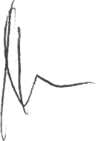
Cooperate Services DDG: Patricia amede Date:

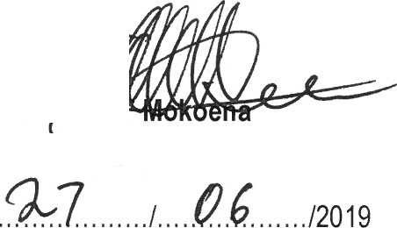Recommendedl

A v
Director General : Department of Mineral Resources

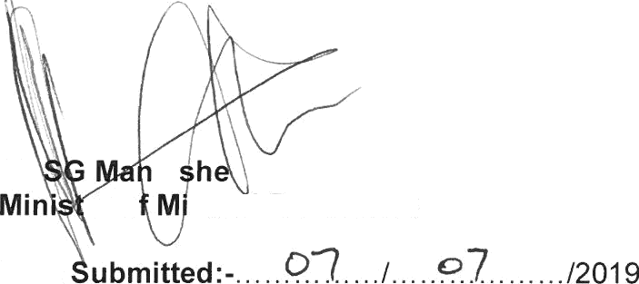ApproUed/ -

Mr ta
er o neral Resources
Date

