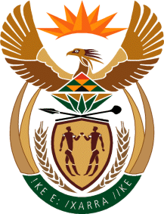

MINISTRY: PUBLIC SERVICE AND ADMINISTRATION
REPUBLIC OF SOUTH AFRICA

NATIONAL ASSEMBLY

QUESTION FOR WRITTEN REPLY

DATE: 11 MARCH 2022

QUESTION NO.: 823.

Dr M M Gondwe (DA) to ask the Minister of Public Service and Administration:

(a) By what date will the Framework for the Professionalisation of the Public Service which was gazetted in December 2020 be implemented across the Public Service and (b) who will be responsible for the (i) roll-out and (ii) implementation of the Framework within the Public Service? NW1002E

REPLY:
- The National Framework Towards Professionalisation of the Public Sector has been finalised. The Socio-Economic Impact Assessment System (SEIAS) is being done on the Framework and it will be submitted for Cabinet consideration during the month of May 2022. The Framework is identified as one of the key interventions in strengthening state capacity and is seen as a long-term intervention. As such, it will be implemented in a phased approach.
b) (i) The Minister for the Public Service and Administration will be responsible for the roll-out (i.e., coordinating and monitoring) of the Framework.

b) (ii) Given that the Framework is aimed at the broader public sector, all relevant public sector departments/institutions will be responsible for the implementation of the Framework. For example, the National Treasury will be responsible for the professionalisation of the supply chain management occupation in collaboration with professional bodies, and other key stakeholders.
End

