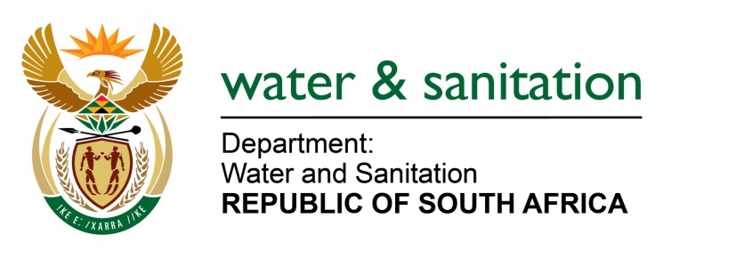

NATIONAL ASSEMBLY

FOR WRITTEN REPLY

QUESTION NO 822

DATE OF PUBLICATION IN INTERNAL QUESTION PAPER: 18 MARCH 2016
(INTERNAL QUESTION PAPER NO. 9)

822. Mr L J Basson (DA) to ask the Minister of Water and Sanitation:

With regard to the water quality of the (a) Umbilo, (b) Palmiet and (c) Vungu rivers in KwaZulu-Natal, (i) what are the greatest risks in each case, (ii) are these risks being monitored and (iii) what action is being taken to reduce these risks? NW941E
---00O00---
REPLY:

(i) There is a need to improve on the microbial quality of the Umbilo River, the nutrient levels of the Palmiet River and in the Vungu River system, nutrients and microbial quality requires improvement.

(ii) Yes, these river systems are being monitored.

(iii) My Department, as well as the eThekwini Municipality has increased the frequency of inspections of hotspot areas to enable early detection of potential problems and allow for swift corrective action. The Department also engages with the Ugu District Municipality at the Ugu Coastal Management Committee where issues relating to pollution are addressed. The Department, together with the respective Municipality, ensures that all the sources of pollution are addressed timeously.

---00O00---

