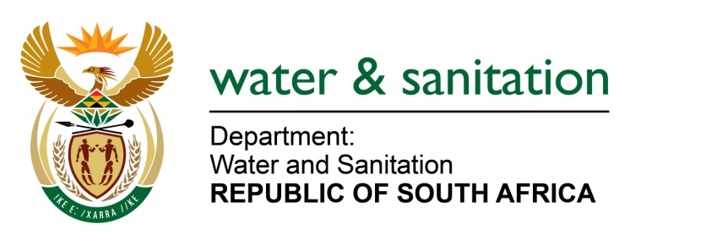

NATIONAL ASSEMBLY

FOR WRITTEN REPLY

QUESTION NO 819

DATE OF PUBLICATION IN INTERNAL QUESTION PAPER: 18 MARCH 2016
(INTERNAL QUESTION PAPER NO. 9)

819. Ms T E Baker (DA) to ask the Minister of Water and Sanitation:
(a) How much does her department owe each of the water boards in the country and (b) what is the detailed age analysis of each debt in each case? NW938E
---00O00---
REPLY:

(a) My Department owes Umgeni Water an outstanding balance of R86 622.19 as at 12 May 2016.

(b) Refer to the table below for the Age Analysis as at 12 May 2016:

Vendor Name |  | To 0 Days | 30 Days |  |  |  | 60 Days |  | 90 Days |  |  | 120 Days |  |  | 150 Days |  | 151+ Days |  |  | Total
UMGENI WATER |  | 0.00 | -86 622.19 |  |  |  | 0.00 |  | 0.00 |  |  | 0.00 |  |  | 0.00 |  | 0.00 |  |  | -86 622.19
---00O00---

