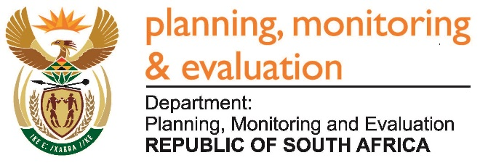 |  | 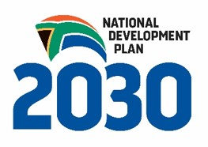
Private Bag X944, PRETORIA, 0001. Union Buildings East Wing, Government Avenue, PRETORIA
Tel: 012 312 0307. www.dpme.gov.za
818. Ms T Stander (DA) to ask the Minister in The Presidency:
Whether his Office has engaged with the Office of Women in The Presidency to discuss the roll out of Project Dignity to provide sanitary towels to vulnerable and poor girls; if not, why not; if so, (a) in what ways will the Office of The Presidency be involved and (b) what are the further relevant details in this regard? NW881E
REPLY:
By virtue of its location in The Presidency, the Office of Women in The Presidency works collaboratively with all the other Offices in the Presidency on matters affecting our communities.
Approved / Not Approved

Mr J T Radebe, MP
Minister in The Presidency
Date:

