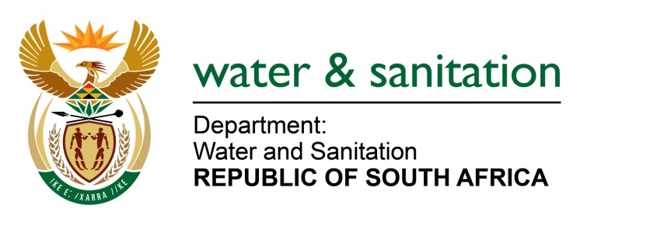

NATIONAL ASSEMBLY

FOR WRITTEN REPLY

QUESTION NO 818

DATE OF PUBLICATION IN INTERNAL QUESTION PAPER: 18 MARCH 2016
(INTERNAL QUESTION PAPER NO. 9)

818. Ms T E Baker (DA) to ask the Minister of Water and Sanitation:

(1) With reference to her reply to question 4225 on 18 December 2015, (a) which of the provinces which have been declared drought disaster areas have approved drought intervention plans in place, (b) what amount has been paid out to each specified province to date and (c) how was this money used;

(2) (a) when were the specified provinces declared drought disaster areas and (b) what are the further relevant details of the gazettes in which they appeared;

(3) (a) which dams in each province have reached levels below the restricted level for abstraction as per the operating rules of each dam, (b) when was this level reached, (c) how many applications were received for further abstraction past the restricted level, (d) how many applications were approved for continued abstraction despite the low levels and (e) what studies and/or assessments were conducted in each case prior to permission being granted;

(4) (a) how many towns across the country have run dry from 1 June 2015 up to the latest specified date for which information is available, (b) what are the names of (i) each town and (ii) each local municipality and (c) what interventions have been put in place in each of the specified towns? NW937E
---00O00---
REPLY:

(1) The KwaZulu-Natal (KZN) province is the only province with approved Business Plan and dedicated budget for drought interventions thus far, refer to Annexure A. All other provinces are using funds which are reprioritized/adjusted within the Departmental budget.
(2) Refer to the table below for the specified provinces declared drought areas.
Province | Date Declared | Type of Declaration
KwaZulu-Natal | 17 December 2014 | Old declaration, Provincial Gazette 167
 | 8 February 2016 | Updated declaration to include 2 additional Municipalities, Provincial Gazette No 1600.
North West | 24 July 2015 | Provincial Gazette 7501
Free State | 4 September 2015 | Provincial Gazette 83
Limpopo | 13 November 2015 | Provincial Gazette 2630
Mpumalanga | 04 December 2015 | Provincial Gazette 2619 (Not all local municipalities in the DM)
Western Cape | 25 November 2015 | Council Resolution
Eastern Cape | 4 December 2015 | Provincial Gazette 3560 Ugi Town declared a Local State of Organic Pollution
 | 22 January 2016 | Provincial Gazette 3582 Council Resolutions in the following DMs: OR Tambo on 11 Jan 2016, Alfred Nzo on 17 Dec 2015.
 | 04 March 2016 | Extension, including Ugu Town Provincial Gazette 3606.
Northern Cape | 29 January 2016 | Provincial Gazette 1983
(3) (a)Restrictions for Dams are applied starting from different levels for different Dams as per the Dam’s operating rules to prevent the Dams from complete failure to supply water or to prolong water supply from each Dam provided the restrictions are adhered to. For additional information on Dam Levels kindly refer to https://www.dwa.gov.za/Hydrology/Weekly/ProvinceWeek
(3)(c) No applications were received for further abstraction past the restricted level.
(3)(d) Not Applicable (N/A).
(3)(e) Annual Operating Analysis is conducted each year at the end of the rainy season to determine allocable amount for the particular year.
(4) Requesting Honorable Member to refer to NA 428 on February 2016 as this question was adequately responded to.
---00O00---

