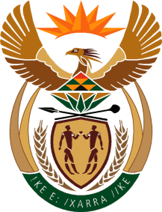

MINISTRY OF TOURISM
REPUBLIC OF SOUTH AFRICA

Private Bag X424, Pretoria, 0001, South Africa. Tel. (+27 12) 444 6780, Fax (+27 12) 444 7027
Private Bag X9154, Cape Town, 8000, South Africa. Tel. (+27 21) 469 5800, Fax: (+27 21) 465 3216

NATIONAL ASSEMBLY:

QUESTION FOR WRITTEN REPLY:
Question Number: 817
Date of Publication: 12 March 2021
NA IQP Number: 8
Date of reply: 31 March 2021

Mr M S F de Freitas (DA) to ask the Minister of Tourism:
With reference to her department and its communication with local stakeholders about relaxing travel restrictions, (a) what communication has been undertaken, (b) with whom has her department communicated, (c) what were the contents of such communication and (d) on what date did such communication take place in each case?
NW976E

REPLY:

- Communication undertaken related to implications of COVID19 outbreak, as well as clarification and awareness raising around the Ministerial directions issued in terms Disaster Management Act. The department’s engagements also focused on health protocols to give confidence to tourists and to ensure that the sector supports the country’s efforts to minimize the spread of COVID19 infection. Finally, the focus was also on recovery and long-term sustainability of the sector post the pandemic.

- The communication was with the industry, media, other departments and organs of the state and the international community.

- Please refer to (a) above for the contents

- Communication started shortly before the first COVID19 case in South Africa and continues to date as the country implements the Risk Adjusted Strategy to maintain a balance between lives and livelihood in the management of the pandemic.

