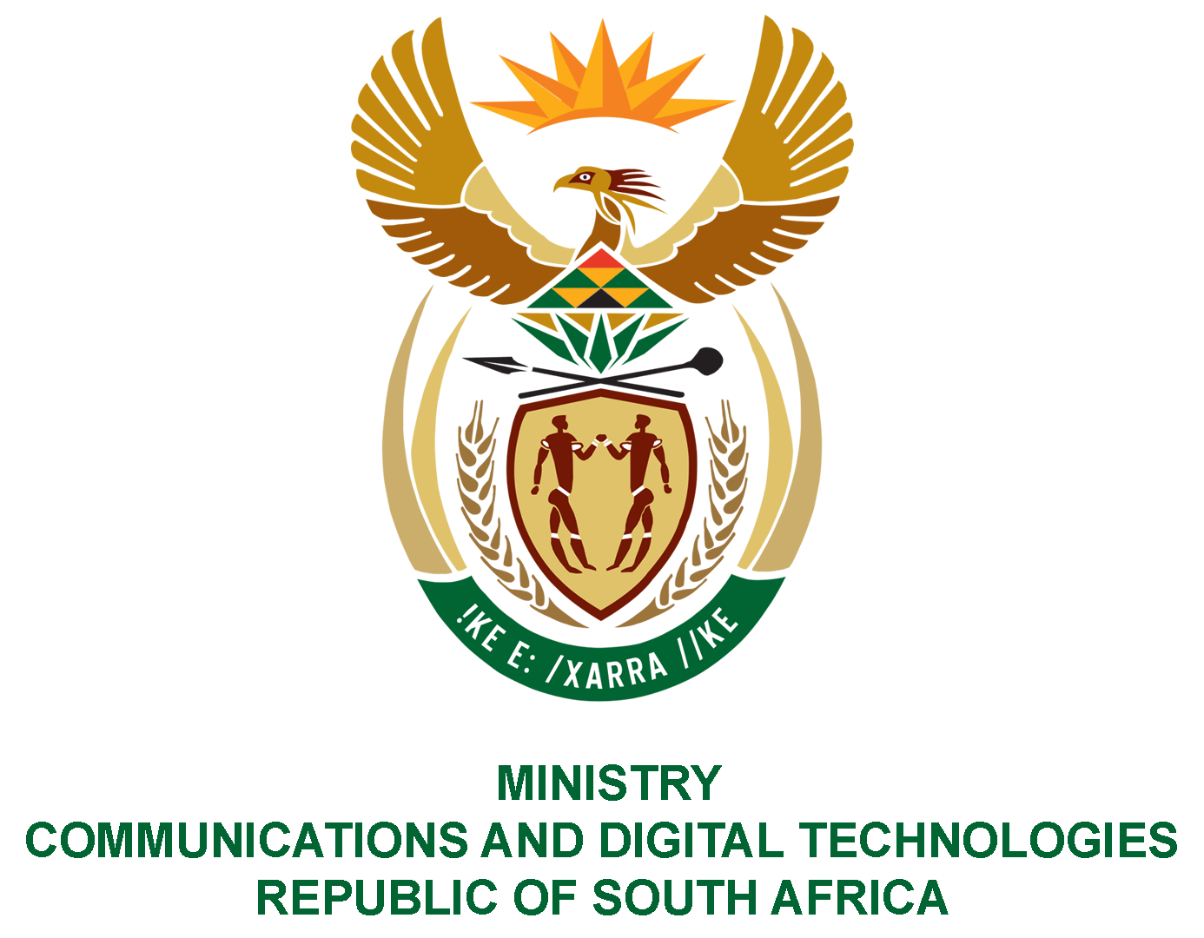

PARLIAMENT OF THE REPUBLIC OF SOUTH AFRICA
NATIONAL ASSEMBLY
WRITTEN REPLY

QUESTION NO: 817
DATE OF PUBLICATION: 15 May 2020
QUESTION PAPER NO: 15

Ms Z Majozi (IFP) to ask the Minister of Communications:

Whether her department has given a concise definition for the term 5G or Fifth Generation wireless communications systems as there appears to be no standardised form of the term; if not, what is the position in this regard; if so, what are the full relevant details?
NW1020E

REPLY:

5G is the fifth generation of wireless technology network adopted by 3rd Generation Partnership Project (3GPP), a standards organisation which develops protocols for mobile telecommunications. 5G is a new globally accepted standard of technology after 3G, 4G and LTE/LTE advanced. 5G is identified by the following use cases: enhanced mobile broadband communications, massive machine type communications, ultra-reliable and low latency communications, and Internet of Things that virtually connects everything and everyone.

MR J MTHEMBU, MP
ACTING MINISTER OF COMMUNICATIONS AND DIGITAL TECHNOLOGIES

