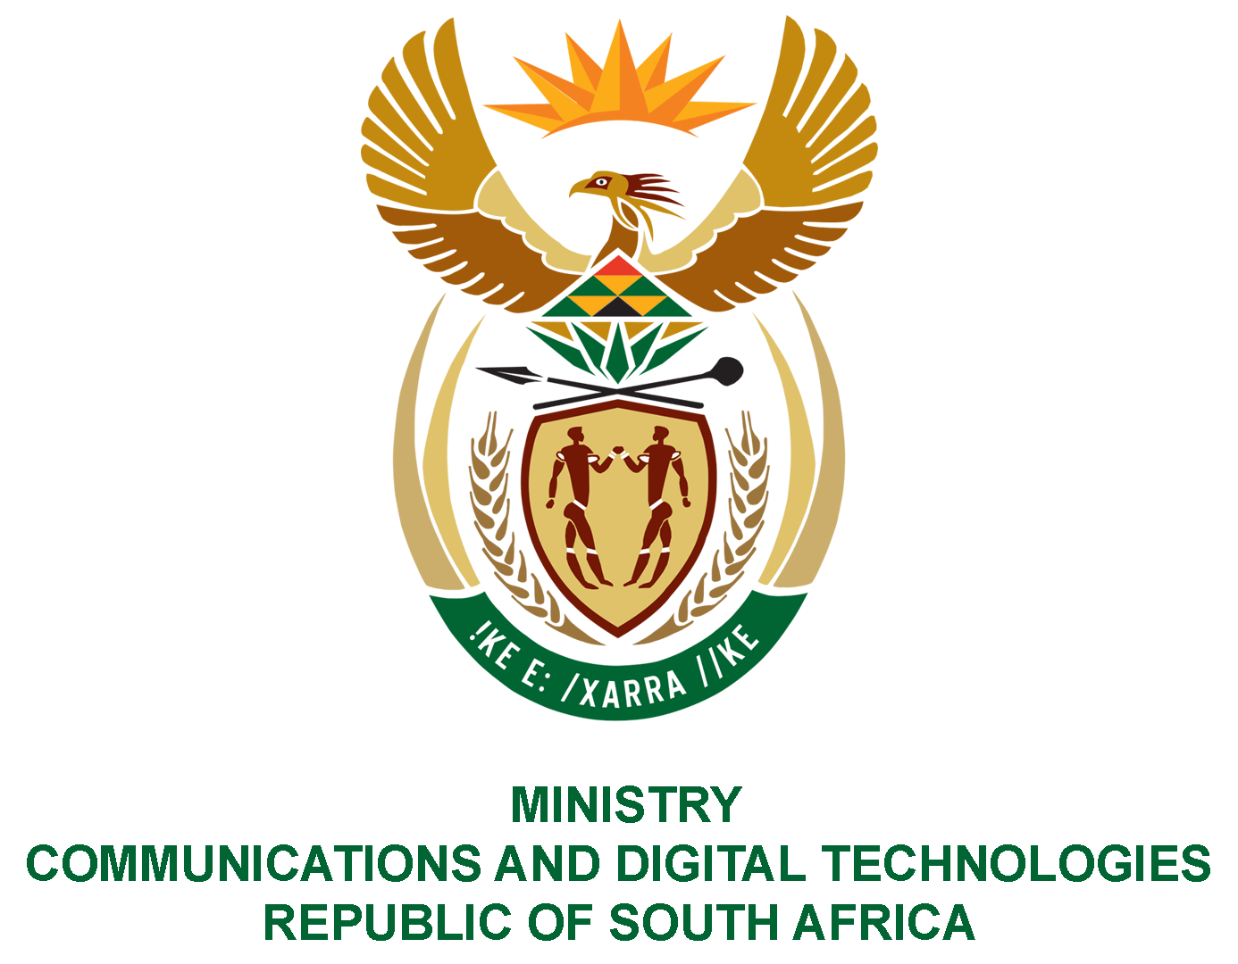

PARLIAMENT OF THE REPUBLIC OF SOUTH AFRICA

NATIONAL ASSEMBLY

WRITTEN REPLY

QUESTION NO: 816
DATE OF PUBLICATION: 11 MARCH
QUESTION PAPER NO: 9

Mr MS Malatsi (DA) to ask the Minister of Communications and Digital Technologies:
What (a) is the total number of SA Post Office branches that were permanently closed since 1 January 2018, (b) are the reasons for each closure and (c) is the physical address of each closed branch? NW995E
REPLY:
I have been advised by SAPO as follows:
- Since 1 January 2018 a total of 248 branches were closed, for various reasons.
(b) Please see attached spread sheet
(c) Please see attached spread sheet

Authorised for submission by:

MS. NONKQUBELA JORDAN-DYANI
DIRECTOR-GENERAL (ACTING)
DATE:

Recommended/not recommended

__________________________
HON. PHILLY MAPULANE, MP
DEPUTY MINISTER
DATE:

Approved/ not approved

________________________________
HON. KHUMBUDZO NTSHAVHENI, MP
MINISTER
DATE:

