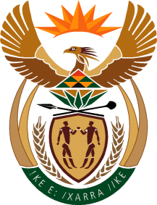

MINISTRY OF TOURISM
REPUBLIC OF SOUTH AFRICA

Private Bag X424, Pretoria, 0001, South Africa. Tel. (+27 12) 444 6780, Fax (+27 12) 444 7027
Private Bag X9154, Cape Town, 8000, South Africa. Tel. (+27 21) 469 5800, Fax: (+27 21) 465 3216

NATIONAL ASSEMBLY:

QUESTION FOR WRITTEN REPLY:
Question Number: 816
Date of Publication: 12 March 2021
NA IQP Number: 8
Date of reply: 01 April 2021

Mr M S F de Freitas (DA) to ask the Minister of Tourism:
With reference to SA Tourism and its communication with local stakeholders about relaxing travel restrictions, (a) what communication has been undertaken, (b) with whom has her department communicated, (c) what were the contents of such communication and (d) on what date did such communication take place in each case? NW975E

REPLY:

- SA Tourism has regularly conducted media interviews on the topic with a wide array of media publications across online, print and broadcast. These interviews ensure that the message around the relaxation of travel restrictions filtered down either through the media publication or the promotion of the interviews via social media platforms.
Furthermore, SA Tourism is constantly liaising with counterparts in the private sector in order to align on efforts to ensure that the message filters down to the trade both nationally and internationally. The last meeting of this sort was held with the following private sector stakeholders, TBCSA, SATSA, SAACI and BARSA.

- SA Tourism has communicated with Provincial tourism authorities, the private sector and media.
- Please refer to ( a) above for the content.
- Communication started shortly before the first COVID19 case in South Africa and continues to date as the
country implements the Risk Adjusted Strategy to maintain a balance between lives and livelihood in the management of the pandemic.

