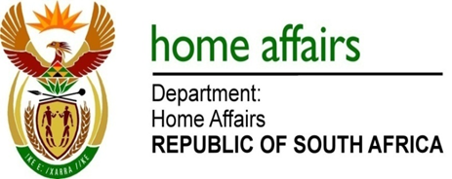

NATIONAL ASSEMBLY

QUESTION FOR WRITTEN REPLY

QUESTION NO. 814

DATE OF PUBLICATION: 16 MARCH 2018

INTERNAL QUESTION PAPER 8 OF 2018

814. The Leader of the Opposition (DA) to ask the Minister of Home Affairs:

Whether (a) he and/or (b) his department ever received any requests from any person at The Presidency to assist with and/or expedite the identity change of any person (i) in each of the past five financial years and (ii) since 1 April 2017; if so, (aa) on what dates, (bb) from whom, (cc) what are the details of the requests and (dd) what are the details of all outcomes? NW899E
REPLY:

(a)&(b) The Ministry and the Department have an established protocol with the Presidency in cases where individual members of the public approach the President of the Republic of South Africa directly (via the Presidency) regarding applications submitted to the Department. Such cases are handled in the same manner as those received from the Public Protector, South African Human Rights Commission and other organisations such as NGOs, where requests from members of the public are referred to the Department to follow-up on the status of such cases.

Requests of this nature that are received by the Presidency are forwarded to Ministry and the office of the Director General which are then disseminated to various branches. As such the volumes cannot be accurately determined to indicate the number of such cases received.

