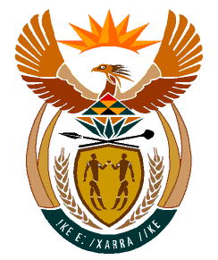

MINISTRY:
HUMAN SETTLEMENTS, WATER AND SANITATION
REPUBLIC OF SOUTH AFRICA

NATIONAL ASSEMBLY

QUESTION FOR WRITTEN REPLY

QUESTION NO.: 813

DATE OF PUBLICATION: 06 SEPTEMBER 2019

Ms E L Powell (DA) to ask the Minister of Human Settlements, Water and Sanitation:
Whether she intends to request that any state-owned parcels of land under the custodianship of the Department of Public Works and Infrastructure be transferred to her department in order to address the housing backlog; if not, what is the position in this regard; if so, what are the relevant details? NW1928E

REPLY:

The Department of Human Settlements has identified 167 well located public land parcels measuring approximately 14 105.1040 hectares. These are held under the custodianship of the National Department of Public Works and Infrastructure and would be appropriate for human settlements development purposes. The proposal for the release of the land parcels is under consideration by the Inter-Ministerial Committee on Land Reform.

