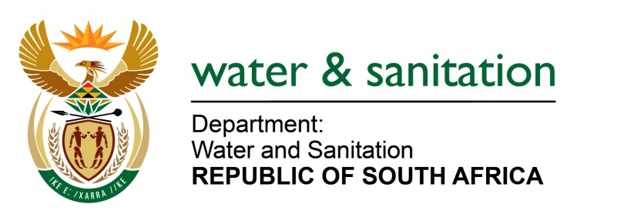

MINISTER OF WATER AND SANITATION

FOR WRITTEN REPLY

QUESTION NO 812

DATE OF PUBLICATION IN INTERNAL QUESTION PAPER: 11 MARCH 2022
(INTERNAL QUESTION PAPER NO. 9)

812. Mr L J Basson (DA) to ask the Minister of Water and Sanitation:

(1) (a) What steps will his department take to rehabilitate the Wilge River in Mpumalanga where effluent water from an un-rehabilitated coalmine destroyed the ecology over a distance of 55 km, (b) what interventions will his department put in place to prevent the ecological destruction from happening again and (c) who is held responsible for the disaster.

(2) what measures will his department put in place in order to (a) monitor and (b) protect our rivers, streams and wetlands from contamination in future;

(3) (a) what total number of un-rehabilitated mines pose a danger of damaging our rivers, (b) will he provide Mr L J Basson with a list of the specified un-rehabilitated mines and (c) how is his department dealing with un-rehabilitated mines that pose a danger of contaminating the water systems?

NW991E
---00O00---
MINISTER OF WATER AND SANITATION

(1)(a) The Department of Water and Sanitation (DWS) issued a Directive instructing the responsible company to appoint a suitably qualified environmental consultant to compile a rehabilitation plan for all the areas affected by the pollution incident. The issued Directive also indicated that the rehabilitation plan ought to have clear timeframes and descriptions of how and when each remedial action will be implemented. The company subsequently submitted the draft rehabilitation plan. The Department has assessed and accepted the rehabilitation plan for implementation however, there are still further investigations that need to be conducted to ensure sustainability.

One of the important aspects that were committed in the draft rehabilitation plan is the ecological restoration of the system. This aspect will be implemented over time as containment or curbing of pollution is prioritised to prevent potential immigration. The DWS is currently monitoring implementation of compliance to the Directive to ensure all reasonable measures are taken to contain and minimise the effects of the incident.

Further, the Department together with the representative from the responsible company held a meeting wherein the following matters were confirmed:

- The company will appoint an independent qualified environmental consultant as prescribed in the Directive to develop sustainable rehabilitation plan
- The company will implement remedial measures to minimise and curb pollution, these measures include, amongst others, clean-up of the pollutants from the river system, the removal of fish carcass from the stream
- The company requested approval from the DWS to release water from Bronkhorspruit and Witbank Dams to assist with the flushing of affected areas and the request was granted
- Final Rehabilitation Plan will be submitted on or before 30 April 2022

(1)(b) The Department conducted an investigation after receiving reports of fish kill at Wilge River system. Findings of the investigation revealed that there was a pollution incident that had occurred at Kwezela Colliery on approximately 14 February 2022. The incident was caused by an old Mine shaft that collapsed which led to an overflow of polluted water from the facility into the watercourse. The Department served the facility with a Directive to immediately rectify the contravention. The Department directed the facility to, amongst others:
- take reasonable measures to contain, minimise the effects of pollution incident,
- undertake clean-up procedures,
- remedy the effects of the incident.

The facility submitted an action plan, and the Department is currently monitoring implementation thereof. The DWS has recently engaged the Department of Forestry, Fisheries and the Environment (DFFE) to request the inclusion of criminal investigators from DFFE on the investigative team. The DFFE will therefore be supporting the other government officials, in relation to the criminal investigation, which will determine the criminal liability based on the evidence collected. A decision would then be made by the National Prosecuting Authority on whether or not to prosecute and which parties should be prosecuted.

(1)(c) Kromdraai Mine which is a section of Khwezela Colliery.

(2)(a) The DWS has a compliance monitoring programme to monitor compliance with the conditions of the water use authorisation in terms of water uses including the discharges of water into the water resources. Furthermore, the department has a regular sampling programme which serves as an early warning system to non-compliance or water quality risks.

2(b) The Department has identified and assessed catchments at high risk for acid mine drainage and is developing mitigation plans to proactively manage these aspects.

3(a) The lead authority for mining is the Department of Mineral Resources and Energy (DMRE). The total number of the un-rehabilitated mines can be obtained from the DMRE.

3(b) Although my Department is not the lead authority on un-rehabilitated mines, the DWS is currently in the process of drafting mitigation strategies to address the impacts of Acid Mine Drainage and amongst other things, these include mitigation measures for un-rehabilitated mines which may pose a danger to water resources.

3(c) Until mine closure certificates are obtained, mines are monitored in accordance with their water use authorisation. The department provides comment and input in this process to DMRE. Water use authorisations also include provisions for progressive rehabilitation and mines are monitored in accordance with these provisions.
---00O00---

