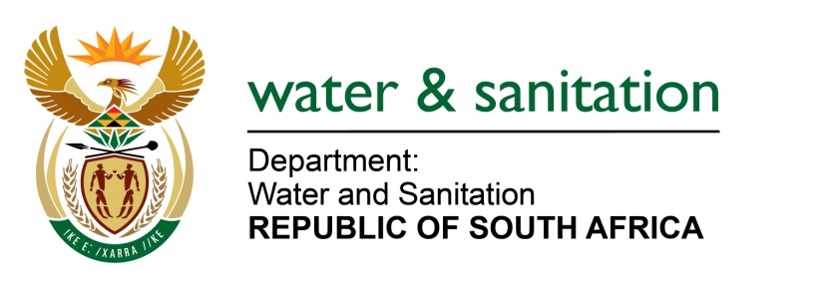

MINISTER OF WATER AND SANITATION

FOR WRITTEN REPLY

QUESTION NO 811

DATE OF PUBLICATION IN INTERNAL QUESTION PAPER: 11 MARCH 2022
(INTERNAL QUESTION PAPER NO. 9)

811. Mr L J Basson (DA) to ask the Minister of Water and Sanitation:

(1) (a) By what date will the work on the 4km feeder canal into the Brandvlei Dam near Worcester be completed, (b) what will be the cost of the work done on the feeder canal and (c) what will be the volume of water increase;
(2) whether there will be further upgrades on the dam; if not, why not; if so, on what date?

NW990E
---00O00---

MINISTER OF WATER AND SANITATION

- (a) The projected date of completion for the project is 22 November 2022.

(b) The total budgeted cost for the project is R21 065 353.73.

(c) 33 million mᶾ of additional water will be stored after completion of the project
(2) The dam safety rehabilitation programme for Kwaggaskloof Dam which forms part of Greater Brandvlei Scheme will commence in the 2022/23 financial year.

---00O00---

