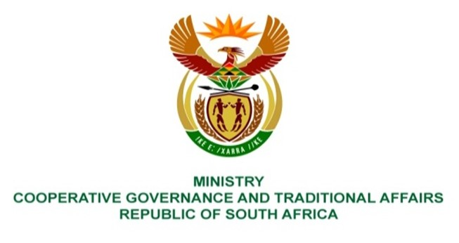

NATIONAL ASSEMBLY
QUESTION FOR WRITTEN REPLY

QUESTION NUMBER 81

- Mrs N I Tarabella Marchesi (DA) to ask the Minister of Cooperative Governance and Traditional Affairs:
What are the details of the (a) make, (b) model, (c) year of manufacture, (d) cost and (e) purchase date of all the official vehicles purchased for (i) her, (ii) the former Minister, (iii) the Deputy Ministers and the (iv) former Deputy Ministers of her department since 1 June 2019? NW81E
REPLY:
Designation | (a) Make | (b) Model | (c) Year of manufacture | (d) Price | (e) Purchase date
(i) Minister Dlamini-Zuma | Volvo | XC60 | 2020 | R806 699.96 | 24 March 2020
(ii) Former Minister | None | None | None | None | None
(iii) Deputy Minister T Nkadimeng | Toyota | Fortuner H50 / A2X | 2023 | R 698 138,55 | January 2023 – Purchase order issued
(iv) Former Deputy Minister | None | None | None | None | None

End.

