FOR WRITTEN REPLY QUESTION 809

NATIONAL ASSEMBLY
36/1/4/1(202000103)

DATE OF PUBLICAYION IN INTERNAL QUEsn o n PAPER: 15 MAY 2020

INTERNAL
UESTION PAPER NO 15-2020

9 S Z Majoré ) IO ask the Ministey p ¡ge,

- With regard tO a report that
SA Police Service (SAPs)

Park Police Station in Durban North were confirmed
two weeks ago and the fact that the
the coronavirus
offïcers at the Green
positive of the coronavirus

at four, what number of police s
Number of confirmed cases is nOw sitting

since the pandemic spread
tations have been affected by to the Republic;

- whether
there are any
intementions in place

to assist

affected stations; if not, why not; if sO, what are the full
With policing at relevant details†
the

REPLY:

(*) Â tOta of 161 bUÏldings, which iFlClude 121 police stations and 40
were decontaminated and closed for
NW1012E

SUpport units

police
stations and
48 hours, as at 19 May 2020. All of thèse
SU)gp Ft Uflits have since been reopened

functioning.

(2) During the process of decontamination, aiternative
ensure continuous service
and are

places were sourced to

deliver
e g mobile commun’ity service centres and

alternative buildings were utilised. The decontamination process
b7 one of the following: The De

was rendered

Managemen
partment of Health, Municipa lity Disaster

t, the South African Police Service (SAPS) Explosives Unit a[ ]d y service providers.
external b

2

Repíy quesúon 809 recommended/

E (SOEG)
Date: gø•0<n czs” 3-1
Reply to question 809 approved/

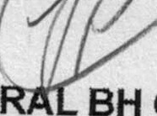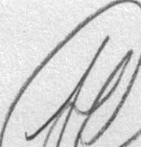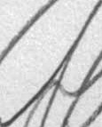f‘’

GENERAL
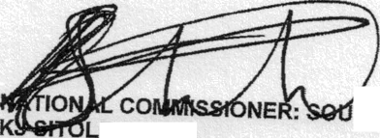TH AFRICAN POLICE SERVICE

GENE

BH CELE (MP)

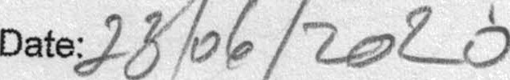
MINISTER OF POȘICÈ

