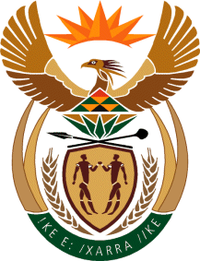

MINISTRY: COMMUNICATIONS
REPUBLIC OF SOUTH AFRICA
Private Bag X 745, Pretoria, 0001, Tel: +27 12 473 0164 Fax: +27 12 473 0585
Tshedimosetso House,1035 Francis Baard Street, Tshedimosetso House, Pretoria, 1000

NATIONAL ASSEMBLY
QUESTION FOR WRITTEN REPLY
QUESTION NUMBER: 806
DATE OF PUBLICATION: MARCH 2016

Ms V van Dyk (DA) to ask the Minister of Communications:
(a) What was the purpose of her attendance at the 2016 World Economic Forum in Davos, Switzerland from 7 to 10 March 2016, (b) what are the (i) names and (ii) positions of the persons who accompanied her and (c) what was the (i) total cost and (ii) breakdown of the costs of the specified trip? NW925E

REPLY: MINISTER OF COMMUNICATIONS
- Minister was not invited to the World Economic Forum in Davos.

(b) (i) not applicable
(ii) not applicable

(c) (i) not applicable
(ii) not applicable

MR NN MUNZHELELE
DIRECTOR GENERAL [ACTING]
DEPARTMENT OF COMMUNICATIONS
DATE:

MS AF MUTHAMBI (MP)
MINISTER OF COMMUNICATIONS
DATE

