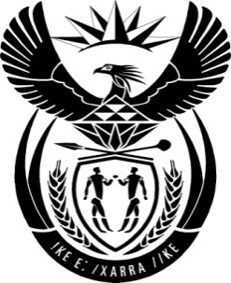

THE PRESIDENCY: REPUBLIC OF SOUTH AFRICA
Private Bag X1000, Pretoria, 0001
NATIONAL ASSEMBLY
QUESTIONS FOR WRITTEN REPLY

QUESTION NO: 806.

Date Published: 20 MARCH 2015

Mr B H Holomisa (UDM) to ask the President of the Republic:

(1) Whether, as the Commander-in-Chief of the defence force, and in respect of the role the Government plays in continental peace efforts, the security forces are in a state of readiness as a fully trained and equipped force to respond to unforeseen and unconventional attacks both from within and outside the Republic;

(2) whether the Government has or intends to have bilateral agreements with other tried and tested countries on unconventional warfare in order to train our personnel? NW464E

REPLY:

- Yes, all South African National Defence Force (SANDF) forces deployed internally and externally are mission ready in terms of both training and equipment.

- Yes, the SANDF has Memoranda of Understanding (MOU’s) with other armed forces in the African continent and beyond in line with the policies of our government and our continental and international obligations. Military training opportunities are exchanged between these friendly forces on continuous basis.

