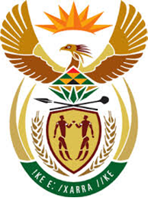

DEPARTMENT: PUBLIC ENTERPRISES
REPUBLIC OF SOUTH AFRICA

NATIONAL ASSEMBLY

805. Mr P G Moteka (EFF) to ask the Minister of Public Enterprises
What were the diesel reserves of Eskom as at 17 March 2019 for its power stations which use diesel to generate electricity? NW928E
Reply:
The Parliamentary question has been forward to Eskom and the Department and the Ministry of Public Enterprises awaits their response. Further information will be conveyed to Parliament as soon as the response is received.

