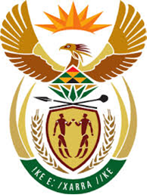

DEPARTMENT: PUBLIC ENTERPRISES
REPUBLIC OF SOUTH AFRICA

NATIONAL ASSEMBLY

803. Mr M M Dlamini (EFF) to ask the Minister of Public Enterprises:
(1) What number of maintenance issues did Eskom power stations experience (a) in the two years before and (b) since he took office as the Minister of Public Enterprises;
(2) (a) what was faulty in each case, (b) on what date was the item last maintained prior to the fault, (c) on what date was the item bought, (d) how long did it take to repair and (e) what amount did it cost to repair in each case? NW926E

Reply:
The Parliamentary question has been forward to Eskom and the Department and the Ministry of Public Enterprises awaits their response. Further information will be conveyed to Parliament as soon as the response is received.

