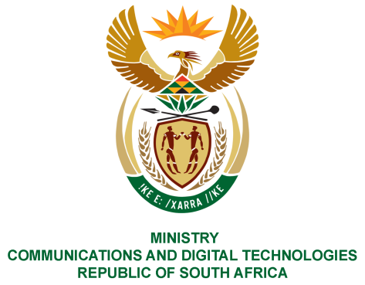
PARLIAMENT OF THE REPUBLIC OF SOUTH AFRICA
NATIONAL ASSEMBLY
WRITTEN REPLY

QUESTION NO: 80
DATE OF PUBLICATION: 10 February 2023
QUESTION PAPER NO: 01

Mr M Bagraim (DA) to ask the Minister of Communications and Digital Technologies:

What are the details of the (a) make, (b) model, (c) year of manufacturer, (d) cost and
(e) purchase date of all the official vehicles purchased for (i) her, (ii) the former Minister, (iii) the Deputy Minister and the (iv) former Deputy Minister since 1 June 2019?
NW 80E

REPLY:
(i) Minster:

(a) Make : NA
(b) Model : NA
(c) Year of manufacturer : NA
(d) Cost : NA
(e) Purchase date : NA

- Former Minster:

(a) Make : Audi
(b) Model : Q5
(c) Year of manufacturer : 2022
(d) Cost : R 726 469-25
(e) Purchase date : 10/01/2022

(iii) Deputy Minster:

(a) Make : NA
(b) Model : NA
(c) Year of manufacturer : NA
(d) Cost : NA
(e) Purchase date : NA

- Former Deputy Minster

(a) Make : BMW
(b) Model : Sedan 12 DC, G30, 520 D
(c) Year of manufacturer : 2021
(d) Cost : R 741 044, 54
(e) Purchase/invoice date : 27/07/2021

Thank You.

