MINISTR Y OF ENERGY

REPUBLIC OF SOUTH AFRICA

PRIVATE BAG x 96, PRETORIA, 0001, Tel (012) 406 7658

PRIVATE BAG x 91 4 1, CAPE TOWN, 8000 (021) 469 6412, FaX ‹021) 465 5980

Memorandum from the Parliamentary Office

National Assembly: 8

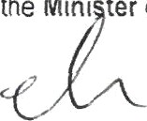Please find axached a response to Parliamentary Question for 'r/ften reply asked by Mr M N Nxumalo (IFP) fo ask the Igini ter of Mineral Resources and Energy

Mr. Jacob Mbele
Deputy Drector-General: Energy Programmes and Projects
.. .. ....../..... . ....../2019

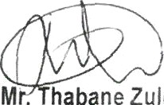Recommended/

M . habane Zulu
Director•General: Department of Energy

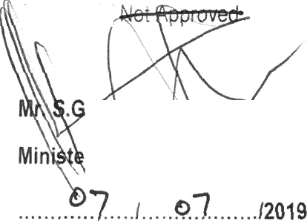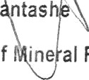Approved/

TO tas ”
r of ine al Resources and Energy

Qtr M N Nxumalo (IFP) to ask the Minister of Mineral Resources and Energy:

- Whether his department is taking any steps to include the youth in the mainstream economy and job creation to ensure active youth involvement, particularly local youth, if not, why not, if so, what are the relevant details,
- what measures wi\\ his department put in place to develop and assist young people into active participation in the mineral resources and energy sector?
NW955E
Reply

- The department has developed Youth Policy in the Energy Sector. The policy seeks to attract young people and create an environment that enables youths to reach their potential in the energy sector. The policy is aimed at addressing amongst others; employment creation, youth economic participation and access to business opportunities, speed up transformation in a way that will benefit young people, enhance skills development to ensure that young people are equipped with necessary skills to enter energy sector job market and access to business opportunities throughout the value chain, outreach projects, youth volunteerism on energy projects, and public private partnenhip.
- There are different measures in place to develop and assist young people to participate in the energy sector:

the measures are as follows:
  - Learners Week (LFW) Programme - The LFW programme is a department’s flagship project focusing on awareness on careers in the energy sector, The programme aims to promote skills development amongst the youth by creating awareness and exposure of career opportunities within the Energy sector for learner doing Science, Technology, Engineering and Mathematics (STEM). The programme targets 250 learners from five provinces per year, whereby the Department of Education in the provinces identifies 50 top Grade 11 12 learners in quintile 1-3 schools doing STEM to pa#icipate in the programme. This year alone the department through our partners (private energy companies) will give 56 bursaries to learners from disadvantage communities to study engineering, computer sciences and other related energy programmes.
  - Integrated Energy Centre Programme - The Integrated Energy Centre (leC) is aimed at enhancing access to energy, stimulate enterprise development and job creation. The IeC trades in petrol, diesel, liquefied petroleum gas, convenience shop and other services such as internet café in other instances. This programme is a partnership between the Department and oil and gas companies The Depa#rrent has established a youth owned Integrated Energy Centre enterprise which will trade in Liquefied

Petroleum Gas in Makhado Local Municipality, Limpopo. This enterprise is expected to be operationalized by July 2019. There are different IeC fuel service stations around the country whose ownership and management include young people.
    - Youth in Energy Dialogues - Youth in Energy Dialogue encompasses youth from different facets with interest in the energy industry and encourage youth to participate in the energy sector as entrepreneurs, investors, professionals, and leaders within the energy field. The dialogues take advantage of th opportunities in the energy sector and how to access them. The dialogue further explore how young people fit into the growing industry and I\ow they can better their industry reach and growth potential to take advantage of this growing sector. The programme showcase opportunities in the energy sector,
    - School Ener9y Days — School Energy Days is aimed at providing and exposing learners in Grade 09 to 11 rural areas in particular studying Science, Technology, Engineering and Mathematics to careers,
opportunities in the energy sector and other energy related information. The department hosts approximately four School Energy Days per year from different provinces in pannership with different Stakeholders and expose them on career opponunities in the energy sector. The event is an appropriate platform to interact with learners on career development, economic development issues and information dissemination on variety of energy issues aimed at:
      - Encourage learners who take STEM to choose energy related career development path
      - Promotion of sustainable use of energy iesou‹ces; and
      - Encourage participation of young people located in rural and developing areas in business opportunities within the energy sector.
In this financial year alone, the Department has already conducted two school energy days in the Eastern Cape with the target of about 700 learners.

