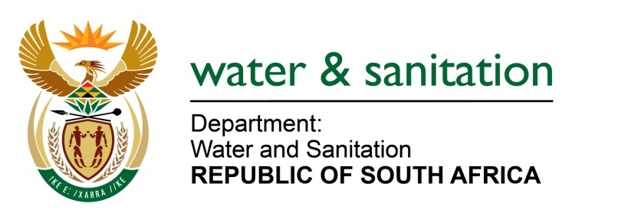

NATIONAL ASSEMBLY

FOR WRITTEN REPLY

QUESTION NO 8

DATE OF PUBLICATION IN INTERNAL QUESTION PAPER: 8 FEBRUARY 2018
(INTERNAL QUESTION PAPER NO. 1)

8. Ms D Carter (Cope) to ask the Minister of Water and Sanitation:
What (a) was the rationale behind the directive from her department to Umgeni Water in terms of section 74(1) of the National Water Act, Act 36 of 1998, to establish a desalination plant in the City of Cape Town, (b) were the legislative provisions she relied on when the directive was issued and (c) are the details of the progress with regard to the establishment of the desalination plant since the directive was issued? NW9E

---00O00---
REPLY:
- The Minister of Water and Sanitation can use the Department of Water and Sanitation and the Agencies/Entities reporting to her to be deployed in emergency situations such as a drought disaster. In the case of the Drought Disaster in the Western Cape and the City of Cape Town in particular, Umgeni Water has both the capacity and the expertise to execute an emergency desalination project and also to perform the operation and maintenance of the plan. Section 74 (1) of the National Water Act, 1998 (Act No. 36 of 1998) provides distinctively for directive relating to a power which already resides with the institution and a power which the institution does not have at all but same assigned or delegated to it by way of a directive. The directive requires that UW performs both water resource and water services functions. It is in this regard that Section 74(1) of the National Water Act, 1998 was utilized as part of the Department of Water and Sanitation intervention.

- Considering the nature of the services (scarce resources) to be provided by Umgeni Water to another organ of state, which will fulfil the right to access to sufficient water in terms of section 27 of the Constitution Act 108 of 1997 but also foster cooperative governance as per section 41 of the Constitution. The fact that the performance of duties assigned to Umgeni Water by the Directive are not in the business plan of Umgeni Water cannot be a legal impediment to enforce the Directive. In fact the purpose of the Directive is to assign or delegate those powers that are not in the business plan or allowable in terms of section 30(1) of the Water Services Act, 1997 (Act No. 108 of 1997) to Umgeni Water.

- Yes. Following meetings between the Mayor of the City of Cape Town (CoCT) and Minister and the request by the Mayor for assistance, Minister issued a directive to UW on 11 December 2017 to procure a 10MLD plant as an emergency intervention for CoCT for siting in the harbour.

- Umgeni Water has concluded their procurement process and has identified a preferred service provider.
- The City of Cape Town have however recently requested that Minister delay the implementation of the desalination option so that they can assess the ground water availability once drilling has been completed, and also to find an alternate site for the plant.
- A number of meetings have been held during the past 10 days to deal with the following issues:
  - Finalisation of the site for the establishment of the plant;
  - Electrical supply;
  - Connector infrastructure (sea intake, brine discharge and connection to the CoCT water supply system);
  - Regulatory requirements; and
  - Off-take agreement.
---00O00---

