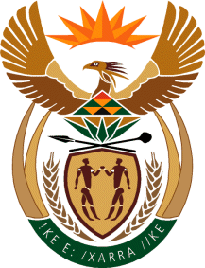
MINISTRY: SPORT AND RECREATION
REPUBLIC OF SOUTH AFRICA

Private Bag X869, Pretoria, 0001, Tel: (012) 304 5158, Fax: (012) 323 8426
Private Bag X9149, Cape Town, 8000, Tel: (021) 465 5506/7/8/9, Fax: (021) 465 4402
_____________________________________________________________________

NATIONAL ASSEMBLY

WRITTEN REPLY

QUESTION PAPER: No. 11 of 24 MARCH 2017

DATE OF REPLY: 21 MAY 2017

797. Mr T W Mhlongo (DA) asked the Minister of Sport and Recreation:
(a) How many sport facilities are currently dysfunctional in each province, (b) what are the reasons in each case, (c) what steps has he taken to rectify the situation in each case and (d) in which municipality is each facility located? NW860E ______________________________________________________________________
The Minister of Sport and Recreation
REPLY:
One of the stumbling blocks to sport development and improving access to participation opportunities has been the absence of an accurate database of sport and recreation facilities. The Department of Sport and Recreation South Africa is thus commencing with a full-scale facilities audit in the 2017/18 financial year. In this period a comprehensive audit will be done in one Province, namely Gauteng. It is expected that the audit of all Provinces will straddle over a number of financial years. Once the audit is complete only then will specific and reliable data be available with regard to the condition of each facility and its location.

