NATIONAL ASSEMBLY
QUESTION FOR WRITTEN REPLY
PARLIAMENTARY QUESTION NO: 782
DATE OF QUESTION: 06 SEPTEMBER 2019

DATE OF SUBMISSION: 20 SEPTEMBER 2019
Adv T E Mulaudzi (EFF) to ask the Minister of Justice and Correctional Services:
(1) (a) What amount was spent on advertising by (i) his department and (ii) state-owned entities reporting to him in the (aa) 2016-17, (bb) 2017-18 and (cc) 2018-19 financial years;
(2) what amount of the total expenditure incurred by (a) his department and (b) state-owned entities reporting to him went to (i) each specified black-owned media company and (ii) outdoor advertising in each specified financial year and (c) on outdoor advertising by his department and state-owned entities reporting to him went to each black-owned media company in each specified financial year?
NW1897E

REPLY:

- (a) (i) The Department of Justice and Constitutional Development has spent as
follows on media buying, both for communications and recruitment purposes:
(aa) 2016/17: R16 698 783.73
(bb) 2017/18: R13 810 961.04; and
(cc) 2018/19: R13 551 618.69
- (a) The Department did not procure any outdoor advertising.

- Entities
- Legal Aid South Africa
- Legal Aid SA has spent as follows in relation to advertising:
(aa) 2016-2017: R5 161 672.00;
(bb) 2017-2018: R4 770 938.00; and
(cc) 2018-2019: R3 300 647.00

- Legal Aid South Africa spent on the following black-owned media companies (in black-owned companies, we considered only B-BBEE Level 1 contributors)
- (i)
Company | Amount for three financial years  2016/17 - 2017/18 | 2016/17 | 2017/18 | 2017/18
South African Broadcast Corporation | R4 014 859.00 | R935 404.00 | R1 189 134.00 | R1 890 321.00
Vuk’uzenzele (GCIS newspaper) | R46 153.00 | R46 154.00
Page 82 | R48 271.00 | R48 271.00
Primedia Outdoor | R 887 346.00 | R471 242.00 | R363 204.00 | R52 900.00
JC Decaux | R76 926.00 | R76 926.00
Thabo Mphelo Films | R17 000.00 | R17 000.00
VK Branding | R82 500.00 |  | R82 500.00
Primedia Broadcast | R194 29.00 |  |  | R194 299.00
Total | R5 367 355.00 | R1 594 997.00 | R1 634 838.00 | R2 137 520.00

- (ii) The table below provides the total amount spent on outdoor advertising:
 | Financial Year | Amount spent on outdoor advertising (Overall) | Amount spent on outdoor advertising  (Black-Owned Media)
(aa) | 2016/17 | R587 913.00 | R519 513.00
(bb) | 2017/18 | R1 331 713.00 | R440 130.00
(cc) | 2018/19 | R1 471 769.00 | R101 170.00

- Special Investigating Unit (SIU)
- Please see the summary of information below in respect to the total amount spent on advertising by the SIU:
(a) (ii) (aa) 2016-17 – R 329’886.00
(bb) 2017-18: R228’476.00
(cc) 2018-19: R729’009.00

- Total amount of the total expenditure incurred by the SIU went to each specified black-owned media company as tabulated below:

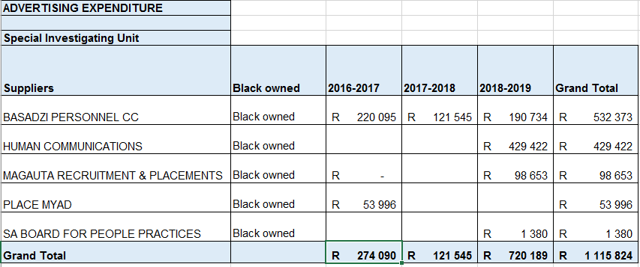

ii) The SIU does not do any outdoor advertising.

- National Prosecuting Authority (NPA)
- (a) The breakdown per year for advertising by the NPA is as follows:
 |  | 2016/17 |  | 2017/18 | 2018/19
 | Advert: Marketing |  | R627 000.00 | - | R34 431.00
 | Advert: Tenders |  | R776.96 | R250.00
 | Total |  | R627 776.96 | R250.00 | R34 431.00

- The table below provides the supplier details of all payments, however there was no spend on outdoor advertising:
Financial Year | Supplier details | Amount | BEE Level | At Least 51% Black Owned | At Least 51% Black Woman Owned | At Least 51% Black Youth Owned
2016/17 | GCIS | R627 000.00 | Government Department
2016/17 | Government Printing Works | R776.96 | Government Department
2017/18 | Government Printing Works | R250.00 | Government Department
2018/19 | African Directory Service | R34 431.00 | 1 | Yes | No | No
Total |  | R662 457.96

- (a)(i) The Office of the Chief Justice spent the below amounts on advertising in the following financial years:
- (aa) R1 066 871 in the 2016/17 financial year;
- (bb) R1 702 403 in the 2017/18 financial year; and
- (cc) R1 724 150 in the 2018/19 financial year.
- (a)(i) The Office of the Chief Justice (i) spent the amounts listed below to companies owned by previously disadvantaged individuals (Black, Coloured and Indian) as follows:
 | 2016/17 |  | 2017/18 |  |  | 2018/19
No | Previously Disadvantaged Companies | Amount | Previously Disadvantaged Companies | Amount | Previously Disadvantaged Companies |  | Amount
1 | Basadzi Personnel CC  (Advert Recruitment) | R94 017.09 | Amcomms The-Can-Do Company  (Advert Recruitment) | R152 152.20 | Basadzi Media  (Advert Recruitment) & (Advert Tenders) |  | R208 612.31
2 | Harriet Dimakatso Multimedia  (Advert Recruitment) | R41 372.43 | Basadzi Media  (Advert Recruitment) & (Advert Tenders) | R29 464.84 | Hermes Communications Solutions  (Advert Recruitment) |  | R20 645.15
3 | Letsatsi Konnexion Centre  (Advert Promotional Items) | R 92 000.00 | Hermes Communications Solutions  (Advert Recruitment) | R52 488.79 | Kone Staffing Solutions  (Advert Recruitment) |  | R155 230.91
4 | Magauta Recruitment & Placement  (Advert Tenders) | R13 520.40 | Indaba Global Travel  (Advert Promotional Items) | R81 106.18 | Magauta Recruitment and Placement  (Advert Recruitment) |  | R123 744.60
5 | Pagliari  (Advert Promotional Items) | R36 519.90 | Jackstar Traders  (Advert Recruitment) | R84 896.02 | Moshate Media  (Advert Recruitment) |  | R328 426.47
6 | SPS Advertising and Marketing  (Advert Promotional Items) | R182 216.46 | KNTE (PTY) (LTD)  (Advert Promotional Items) | R57 548.00 | Seriti Printing Digital  (Advert Promotional Items) |  | R6 848.22
7 | Human Communications  (Advert Recruitment) | R30 408.73 | Kone Staffing Solutions  (Advert Recruitment) | R80 798.64 | SPS Advertising and Marketing  (Advert Promotional Items) |  | R55 165.50
8 | Leopard Rock Office Supplies  (Advert Promotional Items) | R348 344.96 | Magauta Recruitment and Placement  (Advert Recruitment) & (Advert Marketing) | R193 594.80 | Core Marketing Solutions  (Advert Promotional Items) |  | R283 974.68
9 | Madiba Promotions  (Advert Boards) | R8 977.50 | Phaahlana-Mahlako Media Printing  (Advert Promotional Items) | R181 490.40 | Human Communications  (Advert Recruitment) & (Advert Tenders) |  | R74 455.43
10 | M R G Graphics  (Advert Marketing) | R81 777.44 | African Directory Services  (Advert Promotional Items) | R11 397.15 | Madiba Promotions  (Advert Promotional Items) |  | R272 688.00
11 |  |  | Human Communications  (Advert Recruitment) | R34 992.43 | Seriti Printing Digital  (Advert Promotional Items) |  | R7 127.73
12 |  |  | Shaneal Distributors  (Advert Promotional Items) | R1 500.00 | Jetline Midrand  (Advert Promotional Items) |  | R20 261.88
13 |  |  | Highbury Media  (Advert Marketing) | R3 418.86
14 |  |  | Kaqala Media  (Advert Marketing) | R71 250.00
Total | 10 | R1 066 871 | 14 | R1 702 403 | 12 |  | R1 724 150

(2) (a)(ii) The Office of the Chief Justice did not procure outdoor advertising during the specified financial years, therefore, question 2 (c) will not be applicable.

