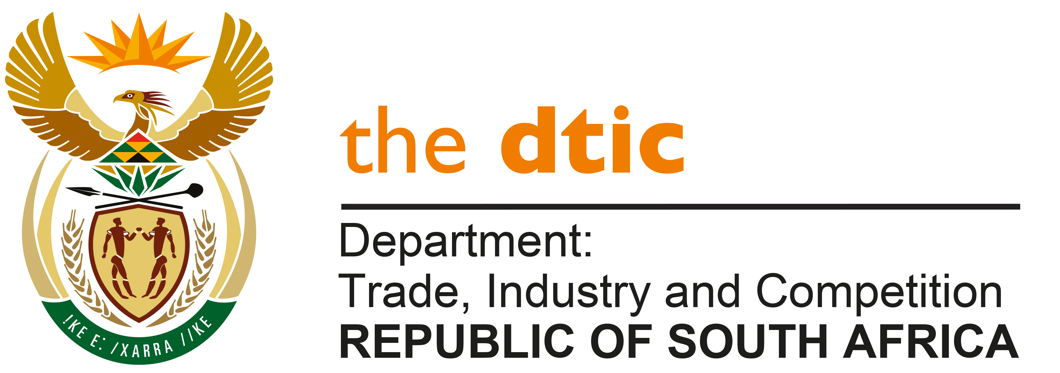

THE NATIONAL ASSEMBLY

QUESTION FOR WRITTEN REPLY

QUESTION NO. 780
DATE PUBLISHED: 11 MARCH 2022

Mrs MO Clarke (DA) to ask The Minister of Trade, Industry and Competition:
(1) The Competition Commissioner advised the Portfolio Committee on Health regarding the National Health Insurance that they have a training programme in place where the state sends officials through the programme to detect collaboration, fraud and corruption and/or any anomalies within the tender processes, which (a) departments have sent their staff through the training and (b) successes has he found have been realised through the training;
(2) whether (a) any benchmarking and/or (b) the setting of Key Performance Indicators have been used to monitor the successes through the training programme; if not, what is the position in this regard; if so, what are the relevant details? [NW958E]

REPLY

(1)(a) The Competition Commission undertakes stakeholder education and training initiatives on various aspects of the Competition Act, to promote compliance to its provisions. For the past five years, training has been focused on Public Procurement, with the following workshops conducted from 01 April 2021 to 14 March 2022:

Dates | Stakeholder | Notes
September 2021 | Auditor General | The Commission provided training on Competition issues in Public Procurement to 180 participants in the Free State and Gauteng Business Units.
February 2022 | Auditor General | The Commission provided training on Competition issues in Public Procurement to over 300 participants in the Mpumalanga and KwaZulu-Natal Business Units.
March 2022 | Auditor General | The Commission provided training on Competition issues in Public Procurement to over 100 participants in the Eastern Cape Business Unit.
March 2022 | Gauteng Department of Roads and Transport | The Commission provided training to officials at the GDRT Competition issues in Public Procurement. The training session also sought to highlight issues related to a particular tender number PPR 2017 and SBD 9 Sub-contracting requirements.

In March 2022, the Commission published a training manual on procurement for officials, entitled: “A Guide on Promoting Competition in Public Procurement”; and a YouTube video entitled: “What Bidders Need To Know About Bid Rigging”.

(2)(a) and (b) The Commission did not conduct any benchmarking exercises, or have key performance indicators in place for this area of work. However, the Commission receives formal and informal feedback on its workshops from the institution/department where the training was provided and directly from workshop participants, all of which has been positive to date. The Commission also regularly receives complaints from government departments- in the main. These complaints are lodged by officials who are either aware of, or have received the Commission’s training on bid-rigging detection. Further, suspicious bid activity is an area which the AG highlights in their audit reports of entities. The relevant entities are expected to engage with the Commission on the matters, as they resolve audit findings.

-END-

