36/1/4/1(2019)
NATIONAL ASSEMBLY

FOR WRITTEN REPLY QUESTION 78
DATE OF PUBLICATION IN INTERNAL QUESTION PAPER: 20 JUNE 2019 (INTERNAL QUESTION PAPER NO 1-2019)

- Mr W T I Mafanya (EFF} to ask the Minister of Police:

  - What number of police stations have permanent counsellors and (b) what are the (i) names and (ii) locations oflhe specified police stations?

NW1035E
REPLY:

- SAPS does not allocate specific counsellors to police stations, a pool of Counsellors that consists of Psychologists, Social Workers and Chaplains get allocated to Provincial or Cluster Office with the intention of offering services to the different stations under that Cluster. The allocation to Clusters or Provincial offices is guided by the following:
  - Number of stations under that cluster
  - Counsellors employed in the province
  - Nature of crime within an area that exposes members to traumatic events and the frequency at which members seek services of a counsellor

One Counsellor can be allocated to service more than two Clusters, especially in rural areas where there is a limited number of counsellors employed by SAPS. Head Office divisions get serviced by a pool of Counsellors who are based at Head Office but get allocated to divisions based on the need.

SAPS currently employ 114 Psychological services professionals, 202 Social Workers and 217 Chaplains country wide.

In areas where there are no SAPS permanent counsellors available, members’ needs are attended to through a Psycho- Social network of proViders contracted to SAPS medical aid POLMED.

TSHIEA
LIEUTENANT GENERAL PERSONNEL MANAGEMENT

QUESTION NO 78: DATE OF PUBLICATION IN INTERNAL QUESTION PAPER: 20 JUNE 2019 (INTERNAL QUESTION PAPER NO 1-2019) ”'"

Reply to question 78 recommended

LIEUTENANT GENERAL DIVISIONAL COM I SIONER: ASSET AND LEGAL MANAGEMENT FN VUMA

Reply to question 78 recommended

AL C
KJ SITOLE (SOEG)

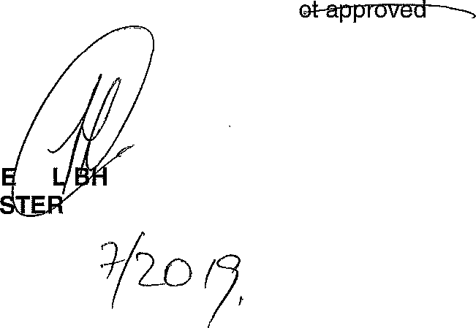Reply to question 78 approved/n

GEN RA CELE (MP) MINI OF POLICE

Date: /
GENERAL UTH AFRICAN POLICE SERVICE

