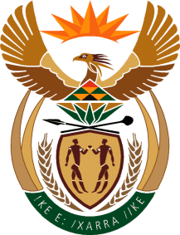

MINISTRY OF TOURISM
REPUBLIC OF SOUTH AFRICA

Private Bag X424, Pretoria, 0001, South Africa. Tel. (+27 12) 444 6780, Fax (+27 12) 444 7027
Private Bag X9154, Cape Town, 8000, South Africa. Tel. (+27 21) 469 5800, Fax: (+27 21) 465 3216

NATIONAL ASSEMBLY:

QUESTION FOR WRITTEN REPLY:
Question Number: 778
Date of Publication: 10 March 2023
NA IQP Number: 8
Date of reply:

Mr M S F de Freitas (DA) to ask the Minister of Tourism:
(1) (a) What processes are being followed in the proposed merger of the SA Tourism and Brand South Africa to date, (b) what milestones have been reached on each date, (c) who are the stakeholders involved in the process and (d) what are the reasons for the delay of the merger to date;
(2) (a) on what date is the merger set to take place, (b) what is the current status of the process and (c) what criteria will be used to select the board of the merged entity and (d) to what ministry will the merged entity report? NW878E

REPLY:

- (a) I have discussed the matter with the Minister in the Presidency responsible for BrandSA. There was no Cabinet decision on the matter as it was scheduled to serve before Cabinet in August 2022 but was withdrawn. The two Ministers have agreed to, first, do a feasibility study and audit the performance of both entities, before a submission is made to Cabinet for consideration.
(b)- (d) Not applicable

- (a) –(d) Not applicable

