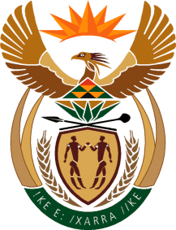

MINISTER OF TOURISM
REPUBLIC OF SOUTH AFRICA

Private Bag X424, Pretoria, 0001, South Africa. Tel. (+27 12) 444 6780, Fax (+27 12) 444 7027
Private Bag X9154, Cape Town, 8000, South Africa. Tel. (+27 21) 469 5800, Fax: (+27 21) 465 3216

NATIONAL ASSEMBLY:

QUESTION FOR WRITTEN REPLY:
Question Number: 773
Date of Publication: 6 September 2019
NA IQP Number: 14
Date of reply: 19 September 2019

Mr K P Sithole (IFP) to ask the Minister of Tourism:
Whether her department can provide the results and findings of the ministerial review of SA Tourism that the former Minister of Tourism commissioned in 2015; if not, why not; if so, what are the full relevant details? NW1875E

Reply:

The Honorable member is referred to website of the Department of Tourism to download the document or alternatively a copy can be supplied by my office by arrangement.

https://www.tourism.gov.za/website/publications/Report%20of%20the%20SA%20Tourism%20Review%20J une%202015.pdf#search=Ministerial%20Review

