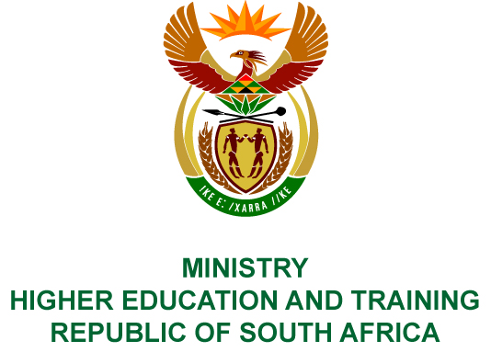
Private Bag X893, Pretoria, 0001, Tel: 012 312 5555, Fax: 012 323 5618
Private Bag X9192, Cape Town, 8000, Tel: 021 469 5150, Fax: 021 465 7956
MEMORANDUM FROM THE PARLIAMENTARY OFFICE
NATIONAL ASSEMBLY
FOR WRITTEN REPLY
QUESTION 770
DATE OF PUBLICATION OF INTERNAL QUESTION PAPER: 20/03/2019
INTERNAL QUESTION PAPER NO 9 OF 2019
Mr A P van der Westhuizen (DA) to ask the Minister of Higher Education and Training:
(1) What number of meetings has the National Qualifications Forum held (a) in each of the past eight calendar years and (b) since 1 January 2019;
(2) whether, with reference to her reply to question 2829 on 21 November 2018, she has found that the lack of activity of the National Qualifications Forum is a matter of concern since the National Qualifications Forum is deemed to be an important forum for her, the chairpersons and chief executive officers of the Quality Councils and the SA Quality Authority to raise issues with one another; if not, what is the position in this regard; if so, what are the relevant details;
(3) what steps will be taken to ensure that the National Qualifications Forum fulfils its mandate in future as envisaged in the National Qualifications Framework Act, Act 67 of 2008, as amended?
NW893E
REPLY:
- (a) The National Qualifications Framework (NQF) Forum held eight meetings in the past eight years.
(b) One NQF Stakeholders Forum meeting was held on 2 March 2019.
- The NQF Forum is an important structure providing the Minister and Director-General with the opportunity to meet with the Chairpersons of the South African Qualifications Authority (SAQA) and Quality Councils to discuss important issues regarding the strategic direction of the NQF, as well as barriers and challenges experienced in the further development and implementation of the NQF. The NQF Forum promotes dialogue and creates a common understanding to ensure the efficient development and implementation of the NQF. I was concerned about the lack of activity of the NQF Forum and actioned the NQF Stakeholders Forum meeting on 2 March 2019 to identify critical issues and continue with the annual NQF Forum meetings.
The Chief Executive Committee is a permanent sub-committee of the NQF Forum and has met quarterly over the past years. It reports to the Minister, Director-General and NQF Forum.
- The Director-General will ensure that the NQF Forum meetings are held. SAQA, as the secretariat of the NQF Forum is tasked to develop a schedule of meetings. Furthermore, Recommendation 4.3 of the Improvement Plan for the Evaluation of the Implementation of the NQF Act (Act No. 67 of 2008) compels the NQF Forum to schedule meetings in advance and the fulfilment of its mandate will be monitored through the Department of Higher Education and Training, and the Department of Performance Monitoring and Evaluation.

COMPILER DETAILS
NAME AND SURNAME: BELLINAH MOLAUDZI
CONTACT: 012 312 5703/5081
RECOMMENDATION
It is recommended that the Minister signs Parliamentary Reply 770.

MR GF QONDE
DIRECTOR–GENERAL: HIGHER EDUCATION AND TRAINING
DATE:

PARLIAMENTARY REPLY 770 IS APPROVED / NOT APPROVED / AMENDED.
COMMENT/S

MRS GNM PANDOR, MP
MINISTER OF HIGHER EDUCATION AND TRAINING
DATE:

