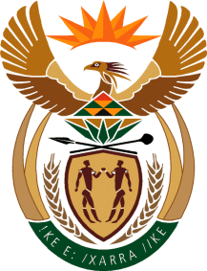

MINISTRY OF TOURISM
REPUBLIC OF SOUTH AFRICA

Private Bag X424, Pretoria, 0001, South Africa. Tel. (+27 12) 444 6780, Fax (+27 12) 444 7027
Private Bag X9154, Cape Town, 8000, South Africa. Tel. (+27 21) 469 5800, Fax: (+27 21) 465 3216

NATIONAL ASSEMBLY:

QUESTION FOR WRITTEN REPLY:
Question Number: 761
Date of Publication: 5 March 2021
NA IQP Number: 6
Date of reply: 01 April 2021

Ms H S Winkler (DA) to ask the Minister of Tourism:
What eco-tourism strategies and/or plans has her department developed and implemented to encourage growth in the tourism sector?
NW884E

REPLY:
The Department of Tourism implements a number of initiatives that support eco-tourism. These include amongst others support for projects in National and Provincial Parks, Heritage Sites and Rural areas in terms of product development and enhancement. Furthermore, the department’s enterprise development programme targets SMMEs that operate within and adjacent to these areas to ensure accrual of benefits to local communities from the growth of tourism activities in such areas. These activities cover amongst others tour operations, accommodation, food etc. An important addition in this regard has been the joint development by the Department of Tourism, SANParks and National Treasury of the framework for concessions, which ensures that transformation imperatives are firmly upheld in the granting of concessions, thereby supporting inclusivity in the growth eco-tourism.

